A Multiscale Quantum-Kinetic Model of Infection-Associated Ultraweak Photon Emission: Structural Uncertainty in the ROS-to-Photon Transfer Function

Horace T. Crogman^{1*}, Gisela Alvarez¹, Peace U. Clement¹, Rohan B. Sonawane², Rakshitha Chidananda, Huzaif Khan² Kwame Eshun³, Hana Nabirahni, Lizeth Rojas, Eugene Joseph⁴, Daniel B. Erenso⁵

¹Department of Physics, California State University Dominguez Hills, Carson CA 90747, USA,
²Department of Computer Science, California State University Dominguez Hills, Carson CA 90747, USA
³Department of Biology, Sierra College, CA 95677, USA,
⁴Department of Biology, La Seirra University, Riverside CA 92505, USA,
⁵Department of Physics and Astronomy, Middle Tennessee State University, Murfreesboro,
Tennessee 37132, USA,

Abstract

Ultraweak photon emission (UPE) is associated with electronically excited molecular products generated during oxidative biochemical reactions, yet the quantitative pathway linking infection-induced reactive oxygen species (ROS) to photon emission remains unresolved. We developed a multiscale quantum-kinetic framework that couples pathogen dynamics, immune activation, signaling ROS, emission-relevant oxidative intermediates, ROS-mediated electron transfer, chemical pumping, excited-state population dynamics, and wavelength-resolved UPE. At the microscopic level, oxidative electron-transfer encounters were represented by a Rabi-like coupling, $Ω_{ROS}=2∣V∣/ℏ$, while randomly timed reactions at the biological scale were reduced to an incoherent chemical-pump process. Literature-derived leukocyte oxidative measurements defined healthy, severe COVID-19, and sepsis regimes with relative ROS levels of 1.00, 9.01, and 13.86, respectively. Because available clinical ROS data and cell-culture UPE data arise from different biological preparations and observation processes, alternative ROS-to-UPE transfer structures were examined rather than assuming a universal mapping. A high-gain structure generated conditional peak-UPE fold changes of approximately 42 for severe COVID-19 and 89 for sepsis, whereas a saturating structure compressed the same oxidative inputs to approximately 1.45-fold in both conditions. The high-gain structure also reproduced a reported PMA/DPI respiratory-burst response, yielding a DPI/PMA UPE ratio of 0.448 under an assumed 50% residual oxidative drive. Global uncertainty and Sobol analyses showed that disease predictions were governed jointly by the clinical ROS input, oxidative-intermediate decay, signaling-to-emission conversion, saturation scale, and composite pump gain. Gaussian, log-normal, and Voigt spectral representations preserved the direction of the predicted wavelength redistribution, although its magnitude remained line-shape dependent. These findings support a common mechanistic pathway from infection-associated oxidative activity to photon emission but demonstrate that current experimental evidence does not uniquely identify a transportable quantitative ROS-to-UPE transfer function. The framework therefore provides structurally constrained, experimentally testable predictions rather than clinically validated disease-specific UPE magnitudes.

Keywords: ultraweak photon emission; reactive oxygen species; chemiexcitation; quantum biology; open quantum systems; electron transfer; Rabi-like coupling; oxidative stress; multiscale modeling; systems biophysics; infection dynamics; structural uncertainty
Interpretation boundary. The disease-specific UPE fold changes reported below are conditional structural predictions. The clinically robust conclusion is that the present literature supports the oxidative-to-photon pathway but does not uniquely determine a universal cross-system transfer function.

- Introduction

Ultraweak photon emission (UPE) is a low-intensity optical phenomenon observed in living biological systems and is widely associated with oxidative metabolic activity. Early foundational studies established that biological systems emit weak photon signals in the visible and near-visible spectral range [1]. Subsequent work has shown that these emissions arise primarily from electronically excited molecular species generated during oxidative reactions, including lipid peroxidation, triplet excited carbonyls, and singlet oxygen-related processes [2,3]. These findings position UPE as a potential optical signature of cellular redox activity and oxidative stress.
A major biological context in which oxidative stress becomes highly dynamic is infection. During infection, pathogens perturb cellular metabolism and activate innate immune responses. Neutrophils, macrophages, and other immune cells generate reactive oxygen species (ROS) through NADPH oxidase-dependent respiratory burst activity [4,5]. ROS play essential roles in antimicrobial defense, inflammatory signaling, and host-pathogen regulation; however, excessive or sustained ROS production can contribute to oxidative tissue damage and dysregulated inflammation [5]. Infection-induced ROS dynamics therefore provide a biologically important link between immune activation, oxidative chemistry, and potential optical emission.
Although UPE has been widely associated with oxidative processes, the mechanistic relationship between infection dynamics and photon emission remains poorly developed. Many experimental studies interpret UPE as an empirical marker of oxidative stress, while mathematical models of infection and ROS dynamics typically focus on biochemical or immunological variables without considering downstream optical emission. Similarly, optical methods such as Raman spectroscopy, fluorescence imaging, and optical coherence tomography have been explored for infectious disease diagnostics, but these approaches often rely on spectral or structural pattern recognition rather than mechanistic modeling of the biochemical processes that generate optical signals [6,7].
Experimental studies using cultured cells have shown that UPE can be monitored dynamically and non-destructively as a marker of oxidative metabolism and redox state [8,9]. However, in vitro systems also introduce confounding factors, including altered oxygen tension, media composition, handling stress, and baseline oxidative artifacts [10,11]. These limitations highlight the need for theoretical models that can distinguish intrinsic biological oxidative dynamics from measurement context and identify the specific processes responsible for photon generation.
A central limitation of many existing approaches is that ROS are treated as a single homogeneous variable. In biological systems, however, ROS species and oxidative products have distinct functions. Some ROS participate primarily in immune signaling and inflammatory regulation, whereas downstream oxidative intermediates, including lipid-peroxidation products and electronically excited molecular species, are more directly associated with photon emission [2,3]. This distinction is essential because total oxidative stress does not necessarily scale linearly with UPE intensity. A mechanistic model of infection-induced UPE should therefore distinguish signaling ROS from emission-relevant oxidative intermediates.
Theoretical descriptions of biological photon emission have traditionally relied on classical chemical kinetics, where photon generation is modeled as a byproduct of oxidative reactions [3,12]. Although these models capture important aspects of UPE generation, they generally do not describe the emitting molecular system using open quantum dynamics. In other biological contexts, open quantum-system approaches have been used to describe dissipative molecular excitation and relaxation processes, including excitonic energy transfer and radical-pair dynamics [13,14]. However, such approaches have not been systematically integrated with infection-driven ROS dynamics to model UPE generation.
To address this gap, we develop a coupled infection-ROS-quantum emission framework that links infection progression, immune activation, oxidative chemistry, and photon emission within a unified dynamical model. The framework introduces two chemically and functionally distinct ROS pools: a signaling ROS pool associated with immune activation and an emission-relevant ROS pool associated with photon-generating oxidative intermediates. The emission-relevant pool drives a nonlinear excitation field, which governs the dynamics of an effective molecular emitter described using an open quantum-system formulation.
This model is designed not merely to reproduce oxidative stress levels, but to predict how biologically calibrated ROS dynamics are transformed into measurable optical signals. Experimentally reported ROS fold-changes from healthy, COVID-19, and sepsis conditions are used to define physiologically relevant oxidative-stress regimes [15]. Within these regimes, the model predicts that UPE does not scale linearly with ROS. Instead, photon emission emerges as a nonlinear, threshold-dependent, and saturating transformation of emission-relevant oxidative activity.
In our recently published multiscale framework, infection dynamics, immune activation, signaling ROS, emission-relevant oxidative chemistry, chemiexcitation, and molecular excited-state populations were connected within a continuous oxidative-to-photon model [16]. That framework established the systems-level pathway and demonstrated that current experimental constraints do not uniquely identify a universal quantitative ROS-to-UPE transfer function. The present study extends that framework by resolving the microscopic excitation step explicitly in terms of ROS-mediated electron transfer, a Rabi-like molecular coupling scale, and its reduction to an incoherent ensemble chemical-pumping process.
In addition to predicting time-dependent emission intensity, the framework is extended to investigate wavelength-dependent emission behavior. Because biological UPE contains contributions from multiple oxidative emitters, including excited carbonyls and singlet oxygen-related bands, infection-induced changes in oxidative chemistry may redistribute the spectral composition of emitted light [2,3]. The spectral extension therefore enables prediction of infection-associated shifts in the effective wavelength distribution of UPE.
The objective of this work is to establish a mechanistic bridge between infection biology, oxidative chemistry, and biophotonic observables. Specifically, the model: (i) links infection dynamics to immune-mediated ROS production; (ii) separates signaling ROS from emission-relevant oxidative intermediates; (iii) formulates photon generation through a nonlinear excitation field; (iv) describes molecular emission using an open quantum-system framework; (v) calibrates oxidative-stress regimes using experimental ROS data; and (vi) predicts both temporal and spectral features of infection-associated UPE. Together, these elements provide a predictive theoretical foundation for interpreting UPE as a nonlinear, time-resolved, and wavelength-dependent optical signature of infection-induced oxidative stress.

2. Multiscale Theoretical Framework

Infection-associated ultraweak photon emission arises from a sequence of biological, chemical, and photophysical processes operating over widely separated temporal and spatial scales. Infection activates host immune cells, including neutrophils and macrophages, which generate reactive oxygen species through NADPH-oxidase-dependent respiratory burst, mitochondrial electron leakage, and related oxidative pathways. These oxidants react with lipids, proteins, nucleic acids, and other biomolecules, producing hydroperoxides, peroxyl radicals, cyclic peroxide intermediates, triplet-excited carbonyls, singlet oxygen, and other electronically excited products capable of radiative relaxation [2- 5,8].
The infection–immune–oxidative–chemiexcitation hierarchy builds on our previously established multiscale ROS-to-UPE framework [16], while the present formulation extends it by introducing an explicit microscopic electron-transfer layer and its connection to open quantum-system dynamics.
The present framework represents this progression as

$$\begin{matrix} & P\left(t\right)⟶E\left(t\right)⟶R_{s}\left(t\right)⟶R_{e}\left(t\right)⟶C_{i}\left(t\right)⟶Ω_{ROS,i}⟶ρ_{i}\left(t\right)⟶I\left(t\right), & & \text{(1)}\end{matrix}$$
where $P\left(t\right)$denotes pathogen burden, $E\left(t\right)$denotes immune activation, $R_{s}\left(t\right)$is the signaling ROS pool, $R_{e}\left(t\right)$is the emission-relevant oxidative pool, $C_{i}\left(t\right)$represents chemiexcitation-capable intermediates, $Ω_{ROS,i}$is the microscopic ROS-mediated electronic coupling frequency of emission channel $i$, $ρ_{i}\left(t\right)$is its density matrix, and $I\left(t\right)$is the total intrinsic photon-emission rate.
The model distinguishes two levels of description. At the microscopic level, an individual oxidative electron-transfer event may transiently couple an unexcited reactant configuration to an electronically excited product configuration. At the ensemble level, many independent and randomly timed reaction events generate an effective incoherent chemical pump. This hierarchy permits transient quantum coherence during individual molecular encounters without requiring macroscopic or long-lived coherence across the biological sample.

2.1. Infection dynamics

The pathogen burden is represented by the normalized variable $P\left(t\right)$. In the absence of immune regulation, pathogen expansion is approximated by logistic growth. Immune-mediated elimination introduces a nonlinear clearance term,

$$\begin{matrix} & \frac{dP}{dt}=r_{P}P\left(1-\frac{P}{K_{P}}\right)-k_{PE}EP, & & \text{(2)}\end{matrix}$$
where $r_{P}$is the intrinsic pathogen-growth rate, $K_{P}$is the effective carrying capacity, and $k_{PE}$is the immune-mediated pathogen-clearance coefficient. This formulation captures the competition between pathogen expansion and host immune control and is consistent with standard within-host infection models [17,18].
The pathogen equation provides the upstream biological input to the model. Pathogen burden does not directly generate photon emission; instead, its optical consequences are mediated by immune activation and oxidative chemistry.

2.2. Immune activation

Innate immune activation generally increases with pathogen burden but approaches saturation because immune-cell recruitment, receptor signaling, and inflammatory responses are finite. The pathogen-dependent activation function is therefore represented using Hill kinetics,

$$\begin{matrix} & H_{P}\left(P\right)=\frac{P^{n_{E}}}{K_{E}^{n_{E}}+P^{n_{E}}}, & & \text{(3)}\end{matrix}$$
where $K_{E}$is the pathogen burden associated with half-maximal activation and $n_{E}$is the effective Hill coefficient.
The immune-response dynamics are
$$\begin{matrix} & \frac{dE}{dt}=k_{EP}\frac{P^{n_{E}}}{K_{E}^{n_{E}}+P^{n_{E}}}-δ_{E}E, & & \text{(4)}\end{matrix}$$
where $k_{EP}$is the maximum immune-activation rate and $δ_{E}$represents immune resolution, regulatory suppression, exhaustion, or cellular turnover.
The explicit immune variable introduces a delay between pathogen growth and oxidative burst. It also prevents the biologically unrealistic assumption that pathogen burden produces ROS instantaneously or directly.

2.3. Signaling ROS dynamics

Activated neutrophils, macrophages, and other immune cells generate ROS through NADPH oxidase and related enzymatic systems. The resulting oxidants contribute to antimicrobial activity, inflammatory signaling, and redox regulation, but not all of them enter photon-producing pathways [4,5](Lambeth, 2004; Nathan & Cunningham-Bussel, 2013).
The signaling ROS pool is modeled as

$$\begin{matrix} & \frac{dR_{s}}{dt}=k_{RE}E-δ_{s}R_{s}, & & \text{(5)}\end{matrix}$$
where $k_{RE}$is the immune-associated ROS-production coefficient and $δ_{s}$represents antioxidant scavenging, enzymatic conversion, diffusion, and chemical consumption.
Under quasi-steady conditions,

$$\begin{matrix} & R_{s,ss}=\frac{k_{RE}}{δ_{s}}E. & & \text{(6)}\end{matrix}$$
Thus, signaling ROS increase with immune activation but remain regulated by antioxidant and clearance processes.
Clinical measurements showing substantially elevated neutrophil ROS generation in severe COVID-19 and sepsis provide the experimental basis for defining disease-associated oxidative regimes in this model [15](Veenith et al., 2022).

2.4. Emission-relevant oxidative chemistry

Signaling ROS do not generally emit photons directly. Instead, they initiate secondary reactions involving lipid peroxidation, protein oxidation, hydroperoxide decomposition, radical recombination, and related pathways. These reactions generate products more directly associated with electronically excited molecular states.
An effective emission-relevant oxidative pool $R_{e}\left(t\right)$is introduced,

$$\begin{matrix} & \frac{dR_{e}}{dt}=k_{se}R_{s}-δ_{e}R_{e}, & & \text{(7)}\end{matrix}$$
where $k_{se}$describes the conversion of signaling oxidative activity into emission-relevant chemistry and $δ_{e}$represents repair, antioxidant interception, spontaneous decomposition, and other non-emissive removal processes.
At quasi-steady state,
$$\begin{matrix} & R_{e,ss}=\frac{k_{se}}{δ_{e}}R_{s,ss}=\frac{k_{RE}k_{se}}{δ_{s}δ_{e}}E. & & \text{(8)}\end{matrix}$$
This two-pool structure separates the biological functions of ROS from the subset of oxidative reactions capable of producing photon-emitting states.

2.5. Formation of chemiexcitation-capable intermediates

The emission-relevant oxidative pool drives the formation of unstable peroxide and radical intermediates. Distinct classes of intermediates are denoted by $C_{i}\left(t\right)$, with each index $i$representing an effective chemiexcitation pathway, such as cyclic peroxide decomposition, tetroxide fragmentation, excited-carbonyl formation, or singlet-oxygen generation.
Their dynamics are represented by

$$\begin{matrix} & \frac{dC_{i}}{dt}=k_{f,i}R_{e}^{m_{i}}-\left(k_{c,i}+k_{d,i}\right)C_{i}, & & \text{(9)}\end{matrix}$$
where $k_{f,i}$is the intermediate-formation coefficient, $m_{i}$is the effective reaction order, $k_{c,i}$is the rate of decomposition through an excitation-producing pathway, and $k_{d,i}$is the rate of competing non-emissive degradation.
The corresponding chemiexcitation-event flux is

$$\begin{matrix} & J_{ch,i}\left(t\right)=Φ_{ch,i}k_{c,i}C_{i}\left(t\right), & & \text{(10)}\end{matrix}$$
where $Φ_{ch,i}$is the probability that decomposition of intermediate $C_{i}$produces an electronically excited molecular product.
Equation (10) is the first explicit connection between oxidative chemical kinetics and molecular electronic excitation.

2.6. Microscopic ROS-mediated electron-transfer system

At the level of an individual oxidative reaction, the system is represented using two effective molecular configurations,

$$\begin{matrix} & \left.\left.∣g_{i}\right\rangle , ∣e_{i}\right\rangle , & & \text{(11)}\end{matrix}$$
where $\left.∣g_{i}\right\rangle$ denotes an unexcited reactant or donor configuration and $\left.∣e_{i}\right\rangle$ denotes an electronically excited product or acceptor configuration capable of subsequent photon emission.
During a reactive molecular encounter, electron transfer couples these configurations through the matrix element

$$\begin{matrix} & V_{i}\left(t\right)=\left\langle e_{i}∣H_{ET,i}\left(t\right)∣g_{i}\right\rangle . & & \text{(12)}\end{matrix}$$
The corresponding two-state Hamiltonian is

$$\begin{matrix} & H_{i}\left(t\right)=\frac{ℏΔ_{i}}{2}σ_{z}+V_{i}\left(t\right)σ_{+}+V_{i}^{*}\left(t\right)σ_{-}, & & \text{(13)}\end{matrix}$$
where $Δ_{i}$is the effective energetic mismatch between the reactant configuration and the electronically excited product configuration.
The coupling matrix element $V_{i}$is determined by molecular orbital overlap, donor–acceptor separation, reaction geometry, dielectric environment, solvent reorganization, and local electrostatic structure. Electron-transfer theory establishes that condensed-phase reaction rates depend on both this electronic coupling and environmental reorganization [19,20] (Marcus, 1956; May & Kühn, 2011). Femtosecond electron-transfer experiments and theoretical analyses in DNA have demonstrated that electronic coupling, energetic mismatch, and tunneling energetics strongly influence charge-transfer dynamics [21-23].
Importantly, the concentration $R_{e}\left(t\right)$does not necessarily increase the electronic coupling of a single encounter complex. Rather, increasing oxidative activity increases the number and frequency of encounter complexes and chemiexcitation events. The microscopic coupling $V_{i}$and the macroscopic event flux $J_{ch,i}$are therefore physically distinct quantities.

2.7. ROS-mediated Rabi-like coupling frequency

For an individual reactive encounter, the off-diagonal electron-transfer coupling defines the Rabi-like frequency
$$\begin{matrix} & & Ω_{ROS,i}\left(t\right)=\frac{2∣V_{i}\left(t\right)∣}{ℏ} & \text{(14)}\end{matrix}$$
This quantity has the same dimensions and mathematical role as the Rabi frequency of a laser-driven two-level system, but its physical origin is different. For optical excitation,

$$\begin{matrix} & Ω_{opt}=\frac{∣μ⋅E∣}{ℏ}, & & \text{(15)}\end{matrix}$$
where $E$ is an electromagnetic field. In the oxidative system,

$$\begin{matrix} & Ω_{ROS,i}=\frac{2∣V_{i}∣}{ℏ}, & & \text{(16)}\end{matrix}$$
where $V_{i}$ is a molecular electron-transfer coupling. Thus, $Ω_{ROS,i}$is not an electromagnetic field generated by ROS; it is a frequency characterizing coherent mixing of two molecular electronic configurations during a reactive encounter.
For approximately constant coupling over an encounter duration $τ$, the generalized oscillation frequency is
$$\begin{matrix} & Ω_{eff,i}=\sqrt{Ω_{ROS,i}^{ 2}+Δ_{i}^{ 2}}. & & \text{(17)}\end{matrix}$$
For an initially unexcited molecule,

$$∣c_{g}\left(0\right)∣^{2}=1, ∣c_{e}\left(0\right)∣^{2}=0,$$
the excited-state probability during the coherent encounter is

$$\begin{matrix} & \boxed{P_{e,i}^{\left(coh\right)}\left(τ\right)=\frac{Ω_{ROS,i}^{ 2}}{Ω_{ROS,i}^{ 2}+Δ_{i}^{ 2}}\sin^{2}\left[\frac{\sqrt{Ω_{ROS,i}^{ 2}+Δ_{i}^{ 2}}}{2}τ\right].} & & \text{(18)}\end{matrix}$$
At effective resonance,
$$Δ_{i}=0,$$
this reduces to
$$\begin{matrix} & P_{e,i}^{\left(coh\right)}\left(τ\right)=\sin^{2}\left(\frac{Ω_{ROS,i}τ}{2}\right). & & \text{(19)}\end{matrix}$$
Equations (18) and (19) describe transient coherent population transfer within a single reaction complex. They do not imply synchronized Rabi oscillations throughout the biological sample.

2.8. Relation to condensed-phase electron-transfer kinetics

In a warm biological environment, molecular configurations fluctuate rapidly and electron-transfer events are influenced by solvent and protein reorganization. Under nonadiabatic conditions, the microscopic coupling may be related to an effective electron-transfer rate using Marcus theory,

$$\begin{matrix} & k_{ET,i}=\frac{2π}{ℏ}∣V_{i}∣^{2}\frac{1}{\sqrt{4πλ_{i}k_{B}T}}\exp\left[-\frac{{\left(ΔG_{i}^{0}+λ_{i}\right)}^{2}}{4λ_{i}k_{B}T}\right], & & \text{(20)}\end{matrix}$$
where $λ_{i}$is the reorganization energy, $ΔG_{i}^{0}$is the reaction free-energy change, $T$is temperature, and $k_{B}$is Boltzmann’s constant[19].
Equation (20) shows that the same microscopic coupling that defines $Ω_{ROS,i}$also contributes quadratically to the observable chemical transition rate. It therefore provides a physically grounded connection between the Rabi-like microscopic description and the macroscopic chemiexcitation flux.
In the reduced model, the effective per-emitter chemical pumping rate is written as,

$$\begin{matrix} & p_{i}\left(t\right)=κ_{i}C_{i}\left(t\right), & & \text{(21)}\end{matrix}$$
where $κ_{i}$incorporates electron-transfer probability, chemiexcitation yield, reactive-complex lifetime, molecular abundance, and trapping of the electronically excited product.
Equivalently, $κ_{i}$may be related schematically to

$$\begin{matrix} & κ_{i}∝Φ_{ch,i}k_{ET,i}. & & \text{(22)}\end{matrix}$$

2.9. Open quantum-system formulation

Electronically excited products interact continuously with vibrations, solvent molecules, proteins, lipids, and other environmental degrees of freedom. These interactions produce radiative decay, non-radiative relaxation, quenching, and dephasing. The density matrix therefore evolves according to the Gorini–Kossakowski–Sudarshan–Lindblad master equation,

$$\begin{matrix} & & \frac{dρ_{i}}{dt}=-\frac{i}{ℏ}\left[H_{0,i} , ρ_{i}\right]+D\left[L_{p,i}\right]ρ_{i}+D\left[L_{r,i}\right]ρ_{i}+D\left[L_{nr,i}\right]ρ_{i}+D\left[L_{q,i}\right]ρ_{i}+D\left[L_{ϕ,i}\right]ρ_{i}, & \text{(23)}\end{matrix}$$
where
$$\begin{matrix} & D\left[L\right]ρ=LρL^{†}-\frac{1}{2}\left(L^{†}Lρ+ρL^{†}L\right). & & \text{(24)}\end{matrix}$$
This form guarantees a physically admissible Markovian evolution of the density matrix [24–26].
The chemical-pumping operator is

$$\begin{matrix} & L_{p,i}=\sqrt{p_{i}\left(t\right)} σ_{+}, & & \text{(25)}\end{matrix}$$
while radiative, non-radiative, and quenching relaxation are represented by

$$\begin{matrix} & L_{r,i}=\sqrt{γ_{r,i}} σ_{-}, & & \text{(26)}\end{matrix} \\ \begin{matrix} & L_{nr,i}=\sqrt{γ_{nr,i}} σ_{-}, & & \text{(27)}\end{matrix}$$
and
$$\begin{matrix} & L_{q,i}=\sqrt{γ_{q,i}} σ_{-}. & & \text{(28)}\end{matrix}$$
Pure dephasing is represented by
$$\begin{matrix} & L_{ϕ,i}=\sqrt{\frac{γ_{ϕ,i}}{2}} σ_{z}. & & \text{(29)}\end{matrix}$$
The total population-relaxation rate is

$$\begin{matrix} & Γ_{1,i}=γ_{r,i}+γ_{nr,i}+γ_{q,i}, & & \text{(30)}\end{matrix}$$
and the coherence-relaxation rate is
$$\begin{matrix} & Γ_{2,i}=\frac{Γ_{1,i}}{2}+γ_{ϕ,i}. & & \text{(31)}\end{matrix}$$

2.10. Population dynamics under chemical pumping

For the incoherently pumped system, the excited-state population

$$P_{e,i}\left(t\right)=ρ_{ee,i}\left(t\right)$$
satisfies
$$\begin{matrix} & & \frac{dP_{e,i}}{dt}=p_{i}\left(t\right)\left[1-P_{e,i}\left(t\right)\right]-Γ_{1,i}P_{e,i}\left(t\right). & \text{(32)}\end{matrix}$$
The first term represents chemically generated population transfer into the excited state, while the second term represents all radiative and non-radiative losses.
For a constant pump rate, the steady-state population is

$$\begin{matrix} & P_{e,i}^{ss}=\frac{p_{i}}{p_{i}+Γ_{1,i}}. & & \text{(33)}\end{matrix}$$
Equation (33) generates a natural saturation mechanism without imposing an arbitrary saturation directly between total ROS and photon emission.
In the weak-pump regime,

$$p_{i}≪Γ_{1,i}, \\ \begin{matrix} & P_{e,i}^{ss}≈\frac{p_{i}}{Γ_{1,i}}. & & \text{(34)}\end{matrix}$$
In the strong-pump regime,
$$p_{i}≫Γ_{1,i}, \\ \begin{matrix} & P_{e,i}^{ss}→1. & & \text{(35)}\end{matrix}$$
Thus, large increases in oxidative chemistry can produce progressively smaller increases in excited-state population once the available emitters become substantially occupied.

2.11. Strong-dephasing reduction of the coherent model

The relationship between the microscopic Rabi-like model and the ensemble chemical-pump model can be demonstrated using the Bloch equations. Defining

$$u_{i}=2\operatorname{Re}{ρ_{ge,i}}, v_{i}=2\operatorname{Im}{ρ_{ge,i}}, w_{i}=ρ_{ee,i}-ρ_{gg,i},$$
the transient coherent dynamics satisfy

$$\begin{matrix} & {\dot{u}}_{i}=-Δ_{i}v_{i}-Γ_{2,i}u_{i}, & & \text{(36)}\end{matrix} \\ \begin{matrix} & {\dot{v}}_{i}=Δ_{i}u_{i}-Ω_{ROS,i}w_{i}-Γ_{2,i}v_{i}, & & \text{(37)}\end{matrix} \\ \begin{matrix} & {\dot{w}}_{i}=Ω_{ROS,i}v_{i}-Γ_{1,i}\left(w_{i}-w_{i,eq}\right). & & \text{(38)}\end{matrix}$$
When
$$Γ_{2,i}≫Ω_{ROS,i},$$
the coherence variables relax much faster than the population. Setting ${\dot{u}}_{i}≈0$and ${\dot{v}}_{i}≈0$gives

$$\begin{matrix} & v_{i}≈-\frac{Ω_{ROS,i}Γ_{2,i}}{Γ_{2,i}^{ 2}+Δ_{i}^{ 2}}w_{i}. & & \text{(39)}\end{matrix}$$
The corresponding effective bidirectional mixing rate is

$$\begin{matrix} & & W_{i}=\frac{Ω_{ROS,i}^{ 2}Γ_{2,i}}{2\left(Γ_{2,i}^{ 2}+Δ_{i}^{ 2}\right)}. & \text{(40)}\end{matrix}$$
The population equation becomes

$$\begin{matrix} & \frac{dP_{e,i}}{dt}=W_{i}\left(1-2P_{e,i}\right)-Γ_{1,i}P_{e,i}. & & \text{(41)}\end{matrix}$$
Equation (41) is the strong-dephasing limit of the coherent two-state dynamics. In the oxidative chemical system, vibrational relaxation, product trapping, bond rearrangement, and solvent reorganization make backward transfer less likely. The ensemble description is therefore represented by the directional chemical pump in Equation (32), with $p_{i}\left(t\right)$determined by the chemiexcitation-event flux.
This derivation shows that the coherent and incoherent descriptions are not contradictory. They correspond to different levels and limits of the same molecular process.

2.12. Transient coherence and effective molecular protection

The baseline model does not require long-lived coherence. Nevertheless, particular molecular environments may reduce dephasing during an individual electron-transfer event through structural confinement, hydrogen-bond networks, reduced solvent accessibility, dielectric screening, or enzyme and macromolecular organization.
An optional molecular-protection factor $s_{i}$may be introduced,
$$0≤s_{i}<1,$$
such that
$$\begin{matrix} & γ_{ϕ,i}^{eff}=\left(1-s_{i}\right)γ_{ϕ,i}^{0}. & & \text{(42)}\end{matrix}$$
Increasing $s_{i}$reduces the effective dephasing rate and extends the interval over which the microscopic dynamics in Equation (18) may remain coherent.
Equation (42) should not be interpreted as evidence that such protection necessarily occurs in the infection system. It defines a testable extension that can be evaluated if molecularly specific coherence times become available. The simulations reported in the present study do not require macroscopic coherence or a nonzero shielding factor.

2.13. Photon-emission rate

The intrinsic photon-emission rate from molecular channel $i$ is

$$\begin{matrix} & I_{i}\left(t\right)=N_{i}γ_{r,i}P_{e,i}\left(t\right), & & \text{(43)}\end{matrix}$$
where $N_{i}$ is the number or effective abundance of available emitters.
The total intrinsic biological emission is

$$\begin{matrix} & & I_{bio}\left(t\right)=\sum_{i=1}^{M}{N_{i}}γ_{r,i}P_{e,i}\left(t\right). & \text{(44)}\end{matrix}$$
For a single channel at steady state,

$$\begin{matrix} & I_{i}^{ss}=N_{i}γ_{r,i}\frac{p_{i}}{p_{i}+Γ_{1,i}}. & & \text{(45)}\end{matrix}$$
In the weak-pump limit,

$$\begin{matrix} & I_{i}^{ss}≈N_{i}\frac{γ_{r,i}}{Γ_{1,i}}p_{i}, & & \text{(46)}\end{matrix}$$
whereas in the strong-pump limit,

$$\begin{matrix} & I_{i}^{ss}→N_{i}γ_{r,i}. & & \text{(47)}\end{matrix}$$
Equations (45)–(47) provide a mechanistic explanation for nonlinear compression: increasing ROS may substantially increase the chemical-pump rate while producing only modest additional peak emission once the emitting population approaches saturation.
The detected photon-count rate is

$$\begin{matrix} & I_{det}\left(t\right)=η_{col}T_{opt}η_{det}I_{bio}\left(t\right)+I_{dark}, & & \text{(48)}\end{matrix}$$
where $η_{col}$is collection efficiency, $T_{opt}$is optical transmission, $η_{det}$is detector quantum efficiency, and $I_{dark}$is the detector-background count rate.

2.14. Wavelength-resolved emission

Biological UPE is broadband because multiple oxidative pathways generate different excited molecular products. Each channel is assigned a normalized spectral line shape $G_{i}\left(λ\right)$, satisfying

$$\begin{matrix} & \int{G_{i}}\left(λ\right) dλ=1. & & \text{(49)}\end{matrix}$$
The wavelength-resolved spectrum is

$$\begin{matrix} & S\left(λ , t\right)=\sum_{i=1}^{M}{I_{i}}\left(t\right)G_{i}\left(λ\right). & & \text{(50)}\end{matrix}$$
The integrated spectrum satisfies

$$\begin{matrix} & \int{S}\left(λ , t\right) dλ=I_{bio}\left(t\right). & & \text{(51)}\end{matrix}$$
The spectral centroid is

$$\begin{matrix} & λ_{c}\left(t\right)=\frac{\int{λ}S\left(λ , t\right) dλ}{\int{S}\left(λ , t\right) dλ}. & & \text{(52)}\end{matrix}$$
Disease-associated spectral changes arise through changes in the relative populations and pump rates of different emitters,

$$p_{i}\left(t\right)=κ_{i}C_{i}\left(t\right),$$
rather than through disease-induced changes in their intrinsic transition wavelengths.
Accordingly, any predicted infection-associated wavelength redistribution should be interpreted as a hypothesis concerning altered emitter populations. It is not a prediction that infection changes the fundamental electronic transition energy of a particular molecule.

2.15. Complete coupled system

The reduced multiscale model can be summarized as

$$\begin{matrix} & \boxed{\begin{aligned}\frac{dP}{dt}&=r_{P}P\left(1-\frac{P}{K_{P}}\right)-k_{PE}EP, \\ \frac{dE}{dt}&=k_{EP}\frac{P^{n_{E}}}{K_{E}^{n_{E}}+P^{n_{E}}}-δ_{E}E, \\ \frac{dR_{s}}{dt}&=k_{RE}E-δ_{s}R_{s}, \\ \frac{dR_{e}}{dt}&=k_{se}R_{s}-δ_{e}R_{e}, \\ \frac{dC_{i}}{dt}&=k_{f,i}R_{e}^{m_{i}}-\left(k_{c,i}+k_{d,i}\right)C_{i}, \\ p_{i}\left(t\right)&=κ_{i}C_{i}\left(t\right), \\ \frac{dP_{e,i}}{dt}&=p_{i}\left(t\right)\left(1-P_{e,i}\right)-Γ_{1,i}P_{e,i}, \\ I_{bio}\left(t\right)&=\sum_{i}{N_{i}}γ_{r,i}P_{e,i}\left(t\right).\end{aligned}} & & \text{(53)}\end{matrix}$$
The microscopic origin of $κ_{i}$is described through the electron-transfer coupling $V_{i}$, the Rabi-like scale $Ω_{ROS,i}=2∣V_{i}∣/ℏ$, environmental reorganization, chemiexcitation yield, and molecular trapping.

2.16. Novelty and physical interpretation

The individual components of this framework are grounded in established infection biology, redox chemistry, electron-transfer theory, open quantum systems, and UPE photochemistry. Its novelty lies in joining these components into a continuous mechanistic hierarchy.

The framework introduces four important distinctions.
First, pathogen burden does not directly generate photons. Infection acts through immune activation and oxidative chemistry.
Second, total ROS is not equated with photon-producing chemistry. Signaling ROS and emission-relevant oxidative intermediates are represented separately.
Third, ROS is not treated as a coherent electromagnetic field. At the microscopic level, an oxidative electron-transfer event produces a molecular coupling $V_{i}$ and the Rabi-like scale,

$$Ω_{ROS,i}=\frac{2∣V_{i}∣}{ℏ}.$$
At the ensemble level, randomly timed chemiexcitation events produce the chemical-pump rate

$$p_{i}\left(t\right)=κ_{i}C_{i}\left(t\right).$$
Fourth, the model derives nonlinear photon emission from finite excited-state occupancy and competing radiative, non-radiative, and quenching pathways. Threshold-like behavior may arise from higher-order oxidative chemistry, while saturation arises naturally from the population equation rather than from an arbitrary direct mapping between total ROS and photon intensity.
The resulting mechanism is therefore

$$\begin{matrix} & \boxed{\begin{aligned}\text{infection}→\text{immune activation}→\text{signaling ROS}→\text{oxidative intermediates} \\ →\text{electron-transfer coupling}→\text{chemical pumping}→\text{excited molecular populations}→\text{UPE}.\end{aligned}} & & \text{(54)}\end{matrix}$$
This formulation retains the physically meaningful insight that individual ROS-mediated electron-transfer events are quantum mechanical, while avoiding the unsupported claim that the biological ROS pool behaves as a coherent laser field.

3. Methods

3.1. Study design and computational architecture

This study used a multiscale computational approach to determine how infection-associated oxidative activity may be converted into UPE. The model links pathogen burden, immune activation, signaling ROS, emission-relevant oxidative chemistry, chemiexcitation-capable intermediates, molecular electronic excitation, and radiative photon emission.
The model was implemented at two complementary physical levels. At the microscopic level, an individual ROS-mediated electron-transfer encounter was represented as a two-state quantum system characterized by an electronic coupling matrix element and a Rabi-like coupling frequency. At the ensemble level, the large number of independently initiated oxidative reactions was represented as an incoherent chemical-pumping process that populated electronically excited molecular states. This separation allowed transient quantum dynamics to be considered at the molecular encounter level without assuming phase synchronization or long-lived coherence across the biological sample.
The complete computational pathway was

$$\begin{matrix} & P\left(t\right)→E\left(t\right)→R_{s}\left(t\right)→R_{e}\left(t\right)→C_{i}\left(t\right)→p_{i}\left(t\right)→P_{e,i}\left(t\right)→I_{bio}\left(t\right), & & \text{(55)}\end{matrix}$$
where $P\left(t\right)$is pathogen burden, $E\left(t\right)$is immune activation, $R_{s}\left(t\right)$is signaling ROS, $R_{e}\left(t\right)$is emission-relevant oxidative activity, $C_{i}\left(t\right)$is the concentration of chemiexcitation-capable intermediate $i$, $p_{i}\left(t\right)$is the effective chemical-pumping rate, $P_{e,i}\left(t\right)$is the electronically excited-state population, and $I_{bio}\left(t\right)$is the intrinsic biological photon-emission rate.
No new human or animal experiments were conducted. Published oxidative-stress measurements and oxidative-UPE intervention data were used as literature constraints on the computational model.

3.2. Biological and oxidative subsystem

The infection, immune, and oxidative subsystems were implemented using the governing equations derived in Section 2. The state vector for the slow biological and chemical subsystem was

$$\begin{matrix} & x_{bio}\left(t\right)={\left[P , \left(t\right) , E , \left(t\right) , R_{s} , \left(t\right) , R_{e}\left(t\right)C_{1}\left(t\right)…C_{M}\left(t\right)\right]}^{T}, & & \text{(56)}\end{matrix}$$
and evolved according to

$$\begin{matrix} & \frac{dx_{bio}}{dt}=F_{bio}\left(t , x_{bio} , θ_{bio}\right), & & \text{(57)}\end{matrix}$$
where $θ_{bio}$contains the infection, immune-response, ROS, and chemiexcitation parameters.
Pathogen burden was initialized at a small positive value,

$$\begin{matrix} & P\left(0\right)=P_{0}>0, & & \text{(58)}\end{matrix}$$
while immune activation, signaling ROS, emission-relevant oxidation, and chemiexcitation intermediates were initially set to their basal values,
$$\begin{matrix} & E\left(0\right)=E_{0}, R_{s}\left(0\right)=R_{s,0}, R_{e}\left(0\right)=R_{e,0}, C_{i}\left(0\right)=C_{i,0}. & & \text{(59)}\end{matrix}$$
For normalized simulations, $E_{0}$, $R_{s,0}$, $R_{e,0}$, and $C_{i,0}$were set to zero and $P_{0}$was assigned a small value relative to the normalized pathogen carrying capacity. Baseline sensitivity tests were also performed using nonzero oxidative background levels to confirm that the principal disease-ordering conclusions did not depend on zero-ROS initialization.
The biological time variable was expressed in hours. All rate constants in the infection, immune, ROS, and intermediate-formation equations were therefore converted to units compatible with hours before integration.

3.3. Literature-constrained oxidative regimes

Healthy, severe COVID-19, and sepsis oxidative regimes were defined using neutrophil-derived oxidative measurements reported by Veenith et al. [15]. The reported median leukocyte immuno-test values were 153 for healthy controls, 1378 for severe COVID-19, and 2120 for sepsis. Disease-associated oxidative fold changes were calculated relative to the healthy median,

$$\begin{matrix} & F_{R,D}^{exp}=\frac{M_{D}}{M_{H}}, & & \text{(60)}\end{matrix}$$
where $M_{D}$is the reported median for disease condition $D$and $M_{H}$is the healthy median. This yielded

$$\begin{matrix} & F_{R,H}^{exp}=1.00, F_{R,C}^{exp}=9.01, F_{R,S}^{exp}=13.86. & & \text{(61)}\end{matrix}$$
These values were used only to constrain the upstream infection–immune–ROS subsystem. They were not used to determine chemiexcitation efficiency, electron-transfer coupling, radiative yield, molecular lifetime, or detector response.
A disease-specific oxidative scaling parameter $α_{D}$was applied to the immune-associated ROS-production coefficient,

$$\begin{matrix} & k_{RE,D}=α_{D}k_{RE,H}. & & \text{(62)}\end{matrix}$$
The value of $α_{D}$was selected so that the simulated peak signaling-ROS ratio satisfied

$$\begin{matrix} & \frac{R_{s,\max{,}D}}{R_{s,\max{,}H}}=F_{R,D}^{exp}. & & \text{(63)}\end{matrix}$$
Equation (63) is a calibration condition rather than an independent validation target. Downstream photon emission remained a model prediction.
Experimental variability was incorporated during uncertainty propagation using the published interquartile ranges. When the original first and third quartiles were available, they were used directly to define the sampling interval. When only the total interquartile width was reported, the corresponding disease distribution was represented by a positive bounded distribution centered on the reported median. No standard deviation or standard error was inferred from an IQR without an explicit distributional assumption.

3.4. Parameterization of oxidative and chemiexcitation pathways

The two-pool ROS subsystem was parameterized using literature-supported ranges for immune ROS generation, antioxidant scavenging, lipid-peroxidation kinetics, hydroperoxide formation, oxidative-intermediate removal, and chemiexcitation. The chemiexcitation-capable intermediates were represented by

$$\begin{matrix} & \frac{dC_{i}}{dt}=k_{f,i}R_{e}^{m_{i}}-\left(k_{c,i}+k_{d,i}\right)C_{i}, & & \text{(64)}\end{matrix}$$
where $k_{f,i}$ is the intermediate-formation coefficient, $m_{i}$is the effective reaction order, $k_{c,i}$is the excitation-producing decomposition rate, and $k_{d,i}$is the competing non-emissive degradation rate.
Both first-order and bimolecular mechanisms were considered,

$$\begin{matrix} & m_{i}=1 \text{and} m_{i}=2, & & \text{(65)}\end{matrix}$$
because oxidative UPE may involve unimolecular peroxide decomposition as well as bimolecular radical-recombination pathways [2,3] (Cifra & Pospíšil, 2014; Pospíšil et al., 2014).
The gross chemiexcitation-event flux was calculated as

$$\begin{matrix} & J_{ch,i}\left(t\right)=Φ_{ch,i}k_{c,i}C_{i}\left(t\right), & & \text{(66)}\end{matrix}$$
where $Φ_{ch,i}$is the probability that decomposition of intermediate $C_{i}$enters an electronically excited product channel.
Parameters with experimentally established values were assigned ranges based on the reported measurement uncertainty. Positive rate constants spanning more than one order of magnitude were sampled log-uniformly. Bounded probabilities, including chemiexcitation yields and radiative quantum yields, were sampled only within
$$\begin{matrix} & 0≤Φ≤1. & & \text{(67)}\end{matrix}$$
All parameter definitions, units, nominal values, uncertainty ranges, sampling distributions, and literature sources must be reported in the final parameter table.

3.5. Microscopic ROS-mediated electron-transfer calculation

For each effective emission channel, an individual reactive encounter was represented by an unexcited configuration $\left.∣g_{i}\right\rangle$and an electronically excited product configuration $\left.∣e_{i}\right\rangle$. Their electron-transfer coupling was defined by

$$\begin{matrix} & V_{i}=\left\langle e_{i}∣H_{ET,i}∣g_{i}\right\rangle . & & \text{(68)}\end{matrix}$$
The corresponding Rabi-like coupling frequency was

$$\begin{matrix} & Ω_{ROS,i}=\frac{2∣V_{i}∣}{ℏ}. & & \text{(69)}\end{matrix}$$
This quantity was not interpreted as an electromagnetic field. It was used as a microscopic measure of electronic mixing during an ROS-mediated reactive encounter.
For a constant coupling over an encounter duration $τ_{i}$, the coherent excited-state probability was calculated as,

$$\begin{matrix} & P_{e,i}^{\left(coh\right)}\left(τ_{i}\right)=\frac{Ω_{ROS,i}^{ 2}}{Ω_{ROS,i}^{ 2}+Δ_{i}^{ 2}}\sin^{2}\left[\frac{\sqrt{Ω_{ROS,i}^{ 2}+Δ_{i}^{ 2}}}{2}τ_{i}\right], & & \text{(70)}\end{matrix}$$
where $Δ_{i}$is the effective energetic mismatch between the two configurations.
When reorganization energies and free-energy changes were available or could be assigned physically plausible ranges, the corresponding condensed-phase electron-transfer rate was calculated using Marcus theory,

$$\begin{matrix} & k_{ET,i}=\frac{2π}{ℏ}∣V_{i}∣^{2}\frac{1}{\sqrt{4πλ_{i}k_{B}T}}\exp\left[-\frac{{\left(ΔG_{i}^{0}+λ_{i}\right)}^{2}}{4λ_{i}k_{B}T}\right], & & \text{(71)}\end{matrix}$$
where $λ_{i}$is the reorganization energy, $ΔG_{i}^{0}$is the reaction free-energy change, $T$is temperature, and $k_{B}$is Boltzmann’s constant [19, 20].
For an encounter lifetime $τ_{c,i}$, the probability of electron transfer was estimated as

$$\begin{matrix} & q_{ET,i}=1-\exp\left(-k_{ET,i}τ_{c,i}\right). & & \text{(72)}\end{matrix}$$
Where molecularly specific values of $V_{i}$, $λ_{i}$, $ΔG_{i}^{0}$, or $τ_{c,i}$were unavailable, these quantities were treated as uncertain microscopic parameters rather than being inferred from the macroscopic ROS fold changes.

3.6. Conversion from microscopic excitation to ensemble chemical pumping

The effective rate of electronically excited product formation was calculated from the chemiexcitation-event flux and the mean transfer probability,

$$\begin{matrix} & J_{ex,i}\left(t\right)=J_{ch,i}\left(t\right)q_{ET,i}. & & \text{(73)}\end{matrix}$$
For an effective abundance $N_{i}$of available molecular emitters, the corresponding per-emitter chemical-pumping rate was,

$$\begin{matrix} & p_{i}\left(t\right)=\frac{J_{ex,i}\left(t\right)}{N_{i}}. & & \text{(74)}\end{matrix}$$
When $C_{i}$and the emitter abundance were normalized, Equation (74) was written in reduced form as

$$\begin{matrix} & p_{i}\left(t\right)=κ_{i}C_{i}\left(t\right), & & \text{(75)}\end{matrix}$$
where $κ_{i}$is a composite parameter containing the intermediate-decomposition rate, chemiexcitation yield, electron-transfer probability, reactive-complex lifetime, and effective emitter abundance.
The dimensionless chemical-pump strength was defined by

$$\begin{matrix} & Ξ_{i}\left(t\right)=\frac{p_{i}\left(t\right)}{Γ_{1,i}}, & & \text{(76)}\end{matrix}$$
where
$$\begin{matrix} & Γ_{1,i}=γ_{r,i}+γ_{nr,i}+γ_{q,i} & & \text{(77)}\end{matrix}$$
is the total population-relaxation rate. Values $Ξ_{i}≪1$, $Ξ_{i}∼1$, and $Ξ_{i}≫1$define weak-pump, transition, and strong-pump regimes, respectively. No common phase was assigned to separate oxidative events. Independent reaction events were therefore combined statistically through $p_{i}\left(t\right)$, not coherently through summation of molecular amplitudes.

3.7. Open quantum-system and population calculations

The ensemble molecular emitter was represented as an incoherently pumped open quantum system. The density-matrix evolution was written as

$$\begin{matrix} & \frac{dρ_{i}}{dt}=-\frac{i}{ℏ}\left[H_{0,i} , ρ_{i}\right]+\sum_{j}{D}\left[L_{j,i}\right]ρ_{i}, & & \text{(78)}\end{matrix}$$
where $D\left[L\right]$is the Lindblad dissipator and the jump operators represented chemical pumping, radiative relaxation, non-radiative decay, quenching, and pure dephasing [24–26] .
The pumping and relaxation operators were

$$\begin{matrix} & L_{p,i}=\sqrt{p_{i}\left(t\right)} σ_{+}, & & \text{(79)}\end{matrix} \\ \begin{matrix} & L_{r,i}=\sqrt{γ_{r,i}} σ_{-}, L_{nr,i}=\sqrt{γ_{nr,i}} σ_{-}, L_{q,i}=\sqrt{γ_{q,i}} σ_{-}. & & \text{(80)}\end{matrix}$$
Pure dephasing was represented by
$$\begin{matrix} & L_{ϕ,i}=\sqrt{\frac{γ_{ϕ,i}}{2}} σ_{z}. & & \text{(81)}\end{matrix}$$
Because the ensemble pump is incoherent and the emitters were initialized without ensemble-level phase coherence, the observable emission dynamics are governed by the excited-state population,

$$\begin{matrix} & \frac{dP_{e,i}}{dt}=p_{i}\left(t\right)\left(1-P_{e,i}\right)-Γ_{1,i}P_{e,i}. & & \text{(82)}\end{matrix}$$
Equation (82) is equivalent to the population equation obtained from the full Lindblad master equation under the conditions used in the disease-scale simulations.
The molecular emitters were initially assigned to their electronic ground states,

$$\begin{matrix} & P_{e,i}\left(0\right)=0. & & \text{(83)}\end{matrix}$$
Probability conservation and positivity were verified throughout every simulation,

$$\begin{matrix} & 0≤P_{e,i}\left(t\right)≤1, \operatorname{Tr}{ρ_{i}}\left(t\right)=1. & & \text{(84)}\end{matrix}$$

3.8. Multiscale time integration

The biological subsystem evolves over hours to days, whereas electron-transfer encounters and excited-state relaxation occur over femtosecond-to-microsecond intervals. Directly integrating all processes on one uniform time grid would therefore be inefficient and potentially numerically unstable.
The model was solved using a multirate strategy. Infection, immune, ROS, and chemiexcitation-intermediate equations were integrated on the biological time scale using an adaptive stiff ordinary differential equation solver. At each biological time point, the chemical-pumping rate $p_{i}\left(t\right)$was calculated from the current intermediate concentration.
Because

$$\begin{matrix} & τ_{e,i}=Γ_{1,i}^{-1}≪τ_{bio}, & & \text{(85)}\end{matrix}$$
the excited-state population was calculated using either the exact local population solution or its quasi-steady approximation,

$$\begin{matrix} & P_{e,i}^{ss}\left(t\right)=\frac{p_{i}\left(t\right)}{p_{i}\left(t\right)+Γ_{1,i}}. & & \text{(86)}\end{matrix}$$
Representative simulations were repeated by directly integrating Equation (82) after converting all photophysical rates to the same time unit. Agreement between the dynamic and quasi-steady solutions was used to verify the timescale-separation approximation.
Microscopic encounter calculations based on Equations (69)–(72) were performed independently on the corresponding short molecular time scale and were used to constrain $q_{ET,i}$or $κ_{i}$. They were not integrated using the hour-scale infection time step.

3.9. Numerical implementation and convergence testing

All calculations were implemented in Python using NumPy [27] for array operations, SciPy [28] for differential-equation integration and numerical optimization, pandas for data organization, and Matplotlib [29] for visualization. The slow biological system was solved using an adaptive stiff solver such as BDF or LSODA. Relative and absolute tolerances were initially set to

$$\begin{matrix} & rtol={10}^{-8}, atol={10}^{-10}, & & \text{(87)}\end{matrix}$$
and representative calculations were repeated with tolerances tightened by at least one order of magnitude. Numerical convergence was accepted when all principal outputs changed by less than 1%.
Simulations were rejected if they produced negative concentrations, non-finite values, loss of density-matrix normalization, or excited-state populations outside the interval $\left[0 , 1\right]$. State variables subject to physical non-negativity were monitored at every accepted solver step rather than corrected only after completion.

3.10. Intrinsic and detected photon emission

The intrinsic photon-emission rate from channel $i$was calculated as

$$\begin{matrix} & I_{i}\left(t\right)=N_{i}γ_{r,i}P_{e,i}\left(t\right), & & \text{(88)}\end{matrix}$$
and the total intrinsic emission was

$$\begin{matrix} & I_{bio}\left(t\right)=\sum_{i=1}^{M}{I_{i}}\left(t\right). & & \text{(89)}\end{matrix}$$
Disease comparisons were performed using $I_{bio}\left(t\right)$, thereby separating biological predictions from instrument-specific collection losses.
When detector-observed counts were required, the forward detection model was

$$\begin{matrix} & I_{det}\left(t\right)=η_{col}T_{opt}η_{det}I_{bio}\left(t\right)+I_{dark}, & & \text{(90)}\end{matrix}$$
where $η_{col}$is collection efficiency, $T_{opt}$is optical transmission, $η_{det}$is detector quantum efficiency, and $I_{dark}$is the dark-count rate. For fold-change comparisons performed using the same detector,

$$\begin{matrix} & \frac{I_{det,D}}{I_{det,H}}=\frac{I_{bio,D}}{I_{bio,H}}, & & \text{(91)}\end{matrix}$$
after background subtraction, because the multiplicative detector terms cancel.

3.11. Model outputs and comparison metrics

The primary biological and photophysical outputs were:

$$\begin{matrix} & R_{s,max}=\max_{t}R_{s}\left(t\right), & & \text{(92)}\end{matrix} \\ \begin{matrix} & R_{e,max}=\max_{t}R_{e}\left(t\right), & & \text{(93)}\end{matrix} \\ \begin{matrix} & C_{i,max}=\max_{t}C_{i}\left(t\right), & & \text{(94)}\end{matrix} \\ \begin{matrix} & p_{i,max}=\max_{t}p_{i}\left(t\right), & & \text{(95)}\end{matrix} \\ \begin{matrix} & I_{max}=\max_{t}I_{bio}\left(t\right), & & \text{(96)}\end{matrix}$$
and cumulative emission,

$$\begin{matrix} & Q=\int_{t_{0}}^{t_{f}}{I_{bio}}\left(t\right) dt. & & \text{(97)}\end{matrix}$$
The time to peak emission was

$$\begin{matrix} & t_{max}=\underset{t}{arg max}I_{bio}\left(t\right). & & \text{(98)}\end{matrix}$$
A relative onset time was defined as the first time at which the emission exceeded 10% of the maximum for that condition,

$$\begin{matrix} & t_{on}=\min\left\{t:I_{bio}\left(t\right)≥0.1I_{max}\right\}. & & \text{(99)}\end{matrix}$$
The oxidative-to-optical delay was calculated as,

$$\begin{matrix} & Δt_{R→I}=t_{max}-t_{R_{e},max}. & & \text{(100)}\end{matrix}$$
Disease-associated fold changes were calculated relative to the healthy condition,

$$\begin{matrix} & F_{I,D}=\frac{I_{\max{,}D}}{I_{\max{,}H}}, F_{Q,D}=\frac{Q_{D}}{Q_{H}}. & & \text{(101)}\end{matrix}$$
The optical compression ratio was,

$$\begin{matrix} & S_{D}=\frac{F_{I,D}}{F_{R,D}^{exp}}. & & \text{(102)}\end{matrix}$$
Values $S_{D}<1$indicate that oxidative differences are compressed into proportionally smaller peak-emission differences.

3.12. Wavelength-Resolved Biological Emission and Detector-Forward Spectral Modeling

Biological ultraweak photon emission is broadband because oxidative chemistry produces multiple electronically excited molecular species with distinct transition energies, radiative yields, lifetimes, and spectral distributions. The wavelength-resolved model therefore treated each oxidative-emission pathway as a separate molecular channel rather than imposing a single universal Gaussian profile.
For emission channel $i$, the time-dependent intrinsic photon-production amplitude was calculated as,

$$\begin{matrix} & A_{i}\left(t\right)=N_{i}γ_{r,i}P_{e,i}\left(t\right), & & \text{(103)}\end{matrix}$$
where $N_{i}$is the effective abundance of emitters associated with channel $i$, $γ_{r,i}$is the corresponding radiative decay rate, and $P_{e,i}\left(t\right)$ is the excited-state population obtained from the open quantum-system calculation.

3.12.1. General spectral representation

Each molecular channel was assigned a normalized intrinsic spectral function,

$$g_{i}\left(E\right),$$
Satisfying

$$\begin{matrix} & \int_{0}^{∞}{g_{i}}\left(E\right) dE=1, & & \text{(104)}\end{matrix}$$
where $E$is photon energy. The intrinsic energy-resolved UPE spectrum was then calculated as

$$\begin{matrix} & S_{E}\left(E , t\right)=\sum_{i=1}^{M}{A_{i}}\left(t\right)g_{i}\left(E\right), & & \text{(105)}\end{matrix}$$
where $M$ is the number of modeled oxidative-emission channels.
This formulation separates two distinct components of the spectral calculation:
- the time-dependent channel amplitudes $A_{i}\left(t\right)$, which emerge from the infection–ROS–chemiexcitation model; and
- the intrinsic channel profiles $g_{i}\left(E\right)$, which describe the molecular transition spectrum.
Disease condition was permitted to alter $A_{i}\left(t\right)$through changes in oxidative chemistry and excited-state population. The intrinsic transition energies and line shapes of a given emitter were held fixed across healthy, COVID-19, and sepsis conditions. Thus, any disease-associated spectral redistribution arose from changes in the relative populations of emitting species rather than from arbitrary disease-dependent displacement of molecular transition energies.

3.12.2. Selection of molecular line shapes

The line-shape representation for each channel was selected according to the strength of the available molecular evidence.
When experimentally measured spectra were available, the measured spectrum was normalized and used directly as an empirical basis function,

$$\begin{matrix} & g_{i}\left(E\right)=g_{i}^{exp}\left(E\right). & & \text{(106)}\end{matrix}$$
For an identified molecular emitter with available electronic-structure and vibrational information, a Franck–Condon vibronic spectrum was used,

$$\begin{matrix} & g_{i}\left(E\right)∝\sum_{ν}{F_{0ν,i}} E_{0ν,i}^{ 3}l_{i}\left(E-E_{0ν,i}\right), & & \text{(107)}\end{matrix}$$
where $F_{0ν,i}$ is the Franck–Condon factor for transition $0→ν$, $E_{0ν,i}$ is the vibronic transition energy, and $l_{i}$ is the homogeneous broadening function. This representation is appropriate for molecularly identified excited carbonyls or other emitters for which quantum-chemical calculations are available[20].
For known emission bands lacking complete vibronic information, a Voigt profile was used,

$$\begin{matrix} & g_{i}^{V}\left(E\right)=g_{i}^{G}\left(E ; σ_{i}\right)*g_{i}^{L}\left(E ; Γ_{i}\right), & & \text{(108)}\end{matrix}$$
where $σ_{i}$ represents inhomogeneous broadening caused by variation in local molecular environments, while $Γ_{i}$ represents lifetime and homogeneous dephasing contributions.
Broad unresolved oxidative-emission backgrounds were represented provisionally using Gaussian or log-normal functions. These empirical profiles were not treated as unique molecular assignments and were included as alternative structural models rather than as fixed physical truths.
Accordingly, the hierarchy of spectral evidence was,

$$\begin{matrix} & \text{measured spectrum}>\text{Franck–Condon spectrum}>\text{Voigt profile}>\text{Gaussian or log-normal approximation}. & & \text{(109)}\end{matrix}$$
The broad oxidative-emission assignments were guided by established UPE mechanisms involving excited carbonyls, oxidized pigments, and singlet-oxygen-related pathways [2,3]. For the singlet-oxygen emission channel, the excited-state lifetime was constrained using the time-resolved luminescence measurements of Egorov et al.[30], which reported a lifetime of approximately 3.09 μs in water.

3.12.3. Conversion from energy to wavelength

Spectral calculations were performed primarily in energy space because molecular transition energies and lifetime broadening are more naturally defined in energy or frequency units. The wavelength-domain spectrum was obtained using

$$E=\frac{hc}{λ},$$
and the corresponding Jacobian transformation,

$$\begin{matrix} & S_{λ}\left(λ , t\right)=S_{E}\left(\frac{hc}{λ} , t\right)\frac{hc}{λ^{2}}. & & \text{(110)}\end{matrix}$$
This transformation is necessary because a symmetric line shape in energy is not generally symmetric in wavelength, particularly for broad biological emission bands.
The modeled wavelength range was selected according to the included molecular channels. Visible and short-near-infrared predictions were evaluated over the experimentally accessible range of the proposed detector. When the monomolecular singlet-oxygen phosphorescence channel near 1270 nm was included, its photophysical lifetime was constrained using time-resolved singlet-oxygen luminescence measurements [30], and the modeled spectral domain was extended beyond 1300 nm. Analyses restricted to 350–900 nm were explicitly described as visible and short-near-infrared calculations rather than complete singlet-oxygen spectra.

3.12.4. Detector-forward spectral model

The intrinsic biological spectrum is not measured directly. Optical collection, spectral transmission, detector quantum efficiency, instrumental resolution, and background all modify the observed signal. The predicted detector spectrum was therefore calculated as

$$\begin{matrix} & S_{det}\left(λ , t\right)=\left[η_{col}\left(λ\right)T_{opt}\left(λ\right)η_{det}\left(λ\right)S_{λ}\left(λ , t\right)\right]*R_{inst}\left(λ\right)+B\left(λ\right), & & \text{(111)}\end{matrix}$$
where:
- $η_{col}\left(λ\right)$ is the wavelength-dependent collection efficiency;
- $T_{opt}\left(λ\right)$ is the optical transmission;
- $η_{det}\left(λ\right)$ is detector quantum efficiency;
- $R_{inst}\left(λ\right)$ is the instrument spectral-response function;
- $B\left(λ\right)$ is wavelength-dependent background;
- and $*$denotes convolution.
Intrinsic biological spectra and detector-observed spectra were analyzed separately. This prevented instrument spectral sensitivity from being misinterpreted as disease-associated biological redistribution.

3.12.5. Spectral output metrics

The time-integrated intrinsic spectrum was

$$\begin{matrix} & {\overset{‾}{S}}_{bio}\left(λ\right)=\int_{t_{0}}^{t_{f}}{S_{λ}}\left(λ , t\right) dt. & & \text{(112)}\end{matrix}$$
The time-integrated spectral centroid was calculated as

$$\begin{matrix} & {\overset{‾}{λ}}_{c}=\frac{\int_{t_{0}}^{t_{f}}{∫}λS_{λ}\left(λ , t\right) dλ dt}{\int_{t_{0}}^{t_{f}}{∫}S_{λ}\left(λ , t\right) dλ dt}. & & \text{(113)}\end{matrix}$$
Band-integrated photon yield was defined by
$$\begin{matrix} & Q_{B}=\int_{t_{0}}^{t_{f}}{\int_{λ∈B}{S_{λ}}}\left(λ , t\right) dλ dt, & & \text{(114)}\end{matrix}$$
where $B$is a specified wavelength interval.
A red-to-blue emission ratio was calculated as

$$\begin{matrix} & R_{RB}=\frac{Q_{B_{red}}}{Q_{B_{blue}}}, & & \text{(115)}\end{matrix}$$
with wavelength intervals defined before simulation and held fixed across disease conditions. Spectral conclusions were based on the collective behavior of the full spectrum, centroid, band yields, and spectral ratios rather than on the centroid alone.

3.13. Global Uncertainty and Sensitivity Analysis of Temporal and Spectral Predictions

Parameter uncertainty was propagated through the full infection–immune–oxidative chemistry–quantum emission–detector model using Latin Hypercube Sampling [31]. The uncertain parameter vector included biological, chemical, quantum, spectral, and instrumental quantities,

$$\begin{matrix} & θ=\left[θ_{bio} , θ_{chem} , θ_{quant} , θ_{spec} , θ_{det}\right]. & & \text{(116)}\end{matrix}$$
The biological and chemical parameter groups included infection growth, immune activation, ROS production and clearance, oxidative-intermediate formation, chemiexcitation yield, and intermediate decay. Quantum parameters included electron-transfer coupling, dephasing, radiative relaxation, non-radiative relaxation, quenching, and emitter abundance.
The spectral parameter group included:
- channel transition energies;
- homogeneous linewidths;
- inhomogeneous linewidths;
- Franck–Condon intensities where available;
- empirical-template uncertainty;
- and the abundance of unresolved background components.
Detector uncertainty included wavelength-dependent collection efficiency, optical transmission, quantum efficiency, spectral resolution, dark counts, and background subtraction.
For measured basis spectra, uncertainty was propagated by resampling within reported measurement error or by bootstrap resampling of the digitized spectrum. For calculated Franck–Condon spectra, uncertainty was propagated through transition energies, oscillator strengths, vibrational displacements, and broadening parameters. Gaussian, Voigt, log-normal, and empirical-template choices were treated as structural alternatives rather than as continuously sampled parameters.
A minimum of 1200 physically valid Latin-hypercube realizations were generated for each disease condition. At every time point and wavelength, the ensemble was summarized using the median, interquartile range, and 95% simulation interval. Sensitivity analyses were performed separately for:
- peak signaling ROS;
- peak emission-relevant oxidation;
- maximum chemical-pump rate;
- peak intrinsic UPE;
- cumulative intrinsic UPE;
- onset time;
- time to peak emission;
- spectral centroid;
- red-to-blue ratio;
- band-integrated photon yields;
- and detector-observed count rates.
Partial Rank Correlation Coefficients were used to screen for monotonic parameter–output relationships while accounting for simultaneous variation of the remaining parameters. Variance-based Sobol analysis was then used to calculate first-order and total-order sensitivity indices,

$$\begin{matrix} & S_{i}=\frac{V_{i}}{V\left(Y\right)}, S_{T_{i}}=1-\frac{V_{-i}}{V\left(Y\right)}, & & \text{(117)}\end{matrix}$$
where $Y$denotes a selected temporal or spectral model output.
Intrinsic and detector-observed spectral outputs were analyzed separately. This allowed parameters governing biological photon generation to be distinguished from parameters governing optical collection and measurement.
Partial Rank Correlation Coefficients (PRCC) were used to screen for monotonic parameter–output relationships while accounting for simultaneous variation of the remaining parameters [32]. Variance-based Sobol analysis was then used to calculate first-order and total-order sensitivity indices [33,34]. Confidence intervals for PRCC and Sobol indices were obtained by bootstrap resampling. Parameter rankings were considered stable when increasing the sampling ensemble produced no material change in the dominant parameter ordering.

3.14. Structural Robustness and Alternative Spectral Models

Structural uncertainty was evaluated because the available literature does not uniquely determine either the oxidative chemiexcitation mechanism or the spectral shape of every biological emitter.

3.14.1. Chemiexcitation structures

The following intermediate-formation models were compared,

$$\begin{matrix} & J_{f,i}=k_{f,i}R_{e}, & & \text{(118)}\end{matrix}$$
for first-order formation,
$$\begin{matrix} & J_{f,i}=k_{f,i}R_{e}^{2}, & & \text{(119)}\end{matrix}$$
for bimolecular formation, and
$$\begin{matrix} & J_{f,i}=k_{f,i}\frac{R_{e}^{m_{i}}}{K_{C,i}^{m_{i}}+R_{e}^{m_{i}}}, & & \text{(120)}\end{matrix}$$
for saturating intermediate formation.
Constant and oxidative-stress-dependent quenching were also compared,
$$γ_{q,i}=γ_{q0,i},$$
and
$$\begin{matrix} & γ_{q,i}\left(t\right)=γ_{q0,i}+k_{q,i}R_{e}\left(t\right). & & \text{(121)}\end{matrix}$$

3.14.2. Spectral structures

The wavelength-resolved model was repeated using the following spectral representations:
- experimentally measured normalized basis spectra;
- calculated Franck–Condon vibronic spectra;
- Voigt profiles;
- Gaussian profiles;
- log-normal profiles;
- alternative numbers and combinations of oxidative-emission channels.
The same intrinsic channel centers and profiles were used for all disease conditions within a given structural model. Only the amplitudes generated by the mechanistic model were allowed to vary with disease.
The spectral result was considered structurally robust when the following remained qualitatively stable across admissible spectral models:
- ordering of total photon yield across disease states;
- direction of the spectral-centroid change;
- ordering of band-integrated photon yields;
- direction of the red-to-blue ratio;
- and identification of the dominant emitting pathway.
A spectral shift was not considered robust merely because one selected Gaussian decomposition produced it. If the predicted shift changed sign, disappeared, or varied markedly across alternative line-shape models, it was classified as hypothesis-generating rather than as a central model prediction.

3.14.3. Coherent and strong-dephasing limits

The microscopic ROS-driven coherent-encounter model and the ensemble chemical-pump model were compared over a range of
$$\begin{matrix} & \frac{Γ_{2,i}}{Ω_{ROS,i}}. & & \text{(122)}\end{matrix}$$
This comparison identified the transition from underdamped transient electronic mixing to overdamped population transfer. Agreement between the strongly dephased coherent calculation and the reduced chemical-pump model was used to verify the multiscale reduction.

3.14.4. Robustness criteria

The principal conclusions were considered structurally robust when the following remained unchanged across the competing biological, chemical, quantum, and spectral formulations:
- healthy, COVID-19, and sepsis emission ordering;
- direction of the PMA/DPI intervention effect;
- sublinear or saturating ROS-to-UPE behavior;
- temporal ordering of ROS, intermediates, pumping, and emission;
- and dominant sensitivity rankings.
Structural-model results were reported separately rather than averaged into a single nominal prediction.

3.15. Respiratory-Burst Inhibition Consistency Test

The oxidative-to-optical pathway was evaluated against the differentiated HL-60 respiratory-burst study reported by Burgos et al.[8]. In that experiment, phorbol 12-myristate 13-acetate (PMA) stimulated respiratory-burst activity and UPE, while diphenyleneiodonium (DPI) reduced the PMA-induced UPE signal by approximately 50–60%. PMA stimulation was represented by an increased ROS-production coefficient,

$$\begin{matrix} & k_{RE,PMA}=α_{PMA}k_{RE,0}, & & \text{(123)}\end{matrix}$$
where $α_{PMA}>1$.
DPI inhibition was represented by a residual oxidative-drive fraction,

$$\begin{matrix} & k_{RE,PMA+DPI}=f_{DPI}k_{RE,PMA}, 0≤f_{DPI}≤1. & & \text{(124)}\end{matrix}$$
No downstream chemiexcitation, quantum, radiative, spectral, or detector parameters were changed between the PMA and PMA+DPI simulations. This restriction ensured that the predicted UPE reduction arose from inhibition of the upstream respiratory-burst pathway. The detector-window calculation was based on the reported spectral sensitivity of the Hamamatsu H7360 photosensor module [35].
Because the experiment employed a detector with sensitivity primarily within the 300–650 nm region, the model comparison was performed using the corresponding detector-window signal,

$$\begin{matrix} & I_{det}^{300-650}\left(t\right)=\int_{300 nm}^{650 nm}{\left[S_{det}\left(λ , t\right)-B\left(λ\right)\right]}dλ. & & \text{(125)}\end{matrix}$$
The peak intervention ratio was

$$\begin{matrix} & R_{DPI}^{peak}=\frac{\max_{t}I_{det,PMA+DPI}^{300-650}\left(t\right)}{\max_{t}I_{det,PMA}^{300-650}\left(t\right)}, & & \text{(126)}\end{matrix}$$
and the cumulative intervention ratio was

$$\begin{matrix} & R_{DPI}^{AUC}=\frac{\int{I_{det,PMA+DPI}^{300-650}}\left(t\right) dt}{\int{I_{det,PMA}^{300-650}}\left(t\right) dt}. & & \text{(127)}\end{matrix}$$
The experimentally reported peak-UPE interval was

$$\begin{matrix} & 0.40≤R_{DPI}^{peak}≤0.50. & & \text{(128)}\end{matrix}$$
When a measured or manufacturer-specified detector-response curve was available, it was used in Equation (125). When only the detector wavelength interval was available, a constant response within the reported interval was used as the nominal approximation and wavelength-dependent alternative responses were tested during uncertainty analysis.
The interpretation of this comparison depended on how $f_{DPI}$was obtained. When $f_{DPI}$was constrained independently using ROS measurements, the predicted UPE ratio constituted an external validation target. When $f_{DPI}$ was selected using the UPE ratio itself, the analysis was described as a pathway-level calibration or consistency test rather than independent validation. This distinction was maintained throughout the Results and Discussion.

3.16. Computational Reproducibility, Spectral Provenance, and Data Availability

All simulations were implemented using a reproducible Python workflow. The computational archive included the biological ODE model, microscopic electron-transfer calculations, chemical-pump reduction, open quantum-system calculations, wavelength-resolved emission model, detector-forward model, uncertainty propagation, sensitivity analyses, structural-model comparisons, and figure-generation routines.
Random-number generators were initialized using fixed seeds. Software package versions, numerical solver settings, error tolerances, initial conditions, simulation intervals, and physical constants were recorded in a machine-readable environment file. For every spectral channel, the archive documented:
- molecular or effective-emitter assignment;
- source publication or database;
- DOI or permanent identifier;
- original spectral units;
- experimental conditions;
- digitization procedure, when applicable;
- normalization method;
- transition energies;
- linewidths;
- line-shape family;
- detector-response correction;
- and any preprocessing or background subtraction.
Experimental spectral templates were stored in their original form and as normalized model inputs. Digitized spectra were accompanied by the original figure reference, axis calibration, digitization software, and an estimate of extraction uncertainty. Quantum-chemically calculated Franck–Condon spectra were accompanied by molecular geometries, electronic-structure methods, basis sets, vibrational frequencies, transition energies, oscillator strengths, and broadening parameters.
The archive also contained:
- nominal parameter values and uncertainty ranges;
- literature-derived disease-calibration data;
- Latin Hypercube and Sobol sampling matrices;
- structural-model identifiers;
- intrinsic and detected spectra;
- time-dependent state trajectories;
- PMA/DPI intervention inputs;
- raw simulation outputs;
- processed summary tables;
- and scripts required to reproduce every figure and result.
Intrinsic biological spectra, detector-processed spectra, and background-corrected signals were stored separately to preserve traceability between the biological model and the measurement model.
Before submission, the complete source code, processed data, spectral templates, detector-response functions, and figure-generation scripts should be deposited in a public repository. The permanent repository identifier should replace the provisional data-availability statement in the final manuscript.

4. Results

4.1. Literature-constrained inputs and microscopic electron-transfer scale

Clinical oxidative regimes were anchored to the neutrophil-derived leukocyte immuno-test (LIT) measurements reported for healthy controls, severe COVID-19, and non-COVID sepsis. Median LIT values were 153, 1378, and 2120, corresponding to nominal disease-to-healthy ratios of 1.00, 9.01, and 13.86, respectively[15]. These values constrained the upstream oxidative amplitude only; no infection-specific photon-emission value was imposed.

Table 1. Selected literature-derived constraints and external molecular priors used in the structural analysis.
Quantity | Central value | Uncertainty / range | Unit | Role in model | Source
Healthy LIT ROS | 153 | 112 | LIT score | Upstream oxidative reference | Veenith et al. 2022
Severe COVID-19 LIT ROS | 1378 | 1276 | LIT score | Clinical oxidative input | Veenith et al. 2022
Sepsis LIT ROS | 2120 | 2024 | LIT score | Clinical oxidative input | Veenith et al. 2022
PMA concentration | 54 | — | nM | Respiratory-burst protocol | Burgos et al. 2017
DPI concentration | 0.9 | — | µM | Inhibition protocol | Burgos et al. 2017
DPI/PMA residual UPE | 0.45 | 0.40–0.50 | ratio | Pathway-level consistency interval | Burgos et al. 2017
Electronic coupling V | 330 | 8–330 | cm⁻¹ | External biomolecular prior | Wan et al. 2002
Reorganization energy λ | 8070 | 4000–11000 | cm⁻¹ | External biomolecular prior | Wan et al. 2002
Singlet-oxygen lifetime | 3.09 | 3.03–3.15 | µs | Photophysical lifetime | Egorov et al. 1989

The microscopic sensitivity calculation used an external biomolecular electronic-coupling prior of 330 cm⁻¹, equivalent to a Rabi-like period of 50.5 fs. The resonant upper-bound calculation produced rapid population exchange, whereas energetic mismatch and dephasing reduced or overdamped the coherent response (Figure 1; Table 2). Because this coupling was measured in a DNA electron-transfer system rather than in infection-associated lipid or protein oxidation, the period is interpreted as an illustrative molecular timescale and not as an infection-specific constant [24].

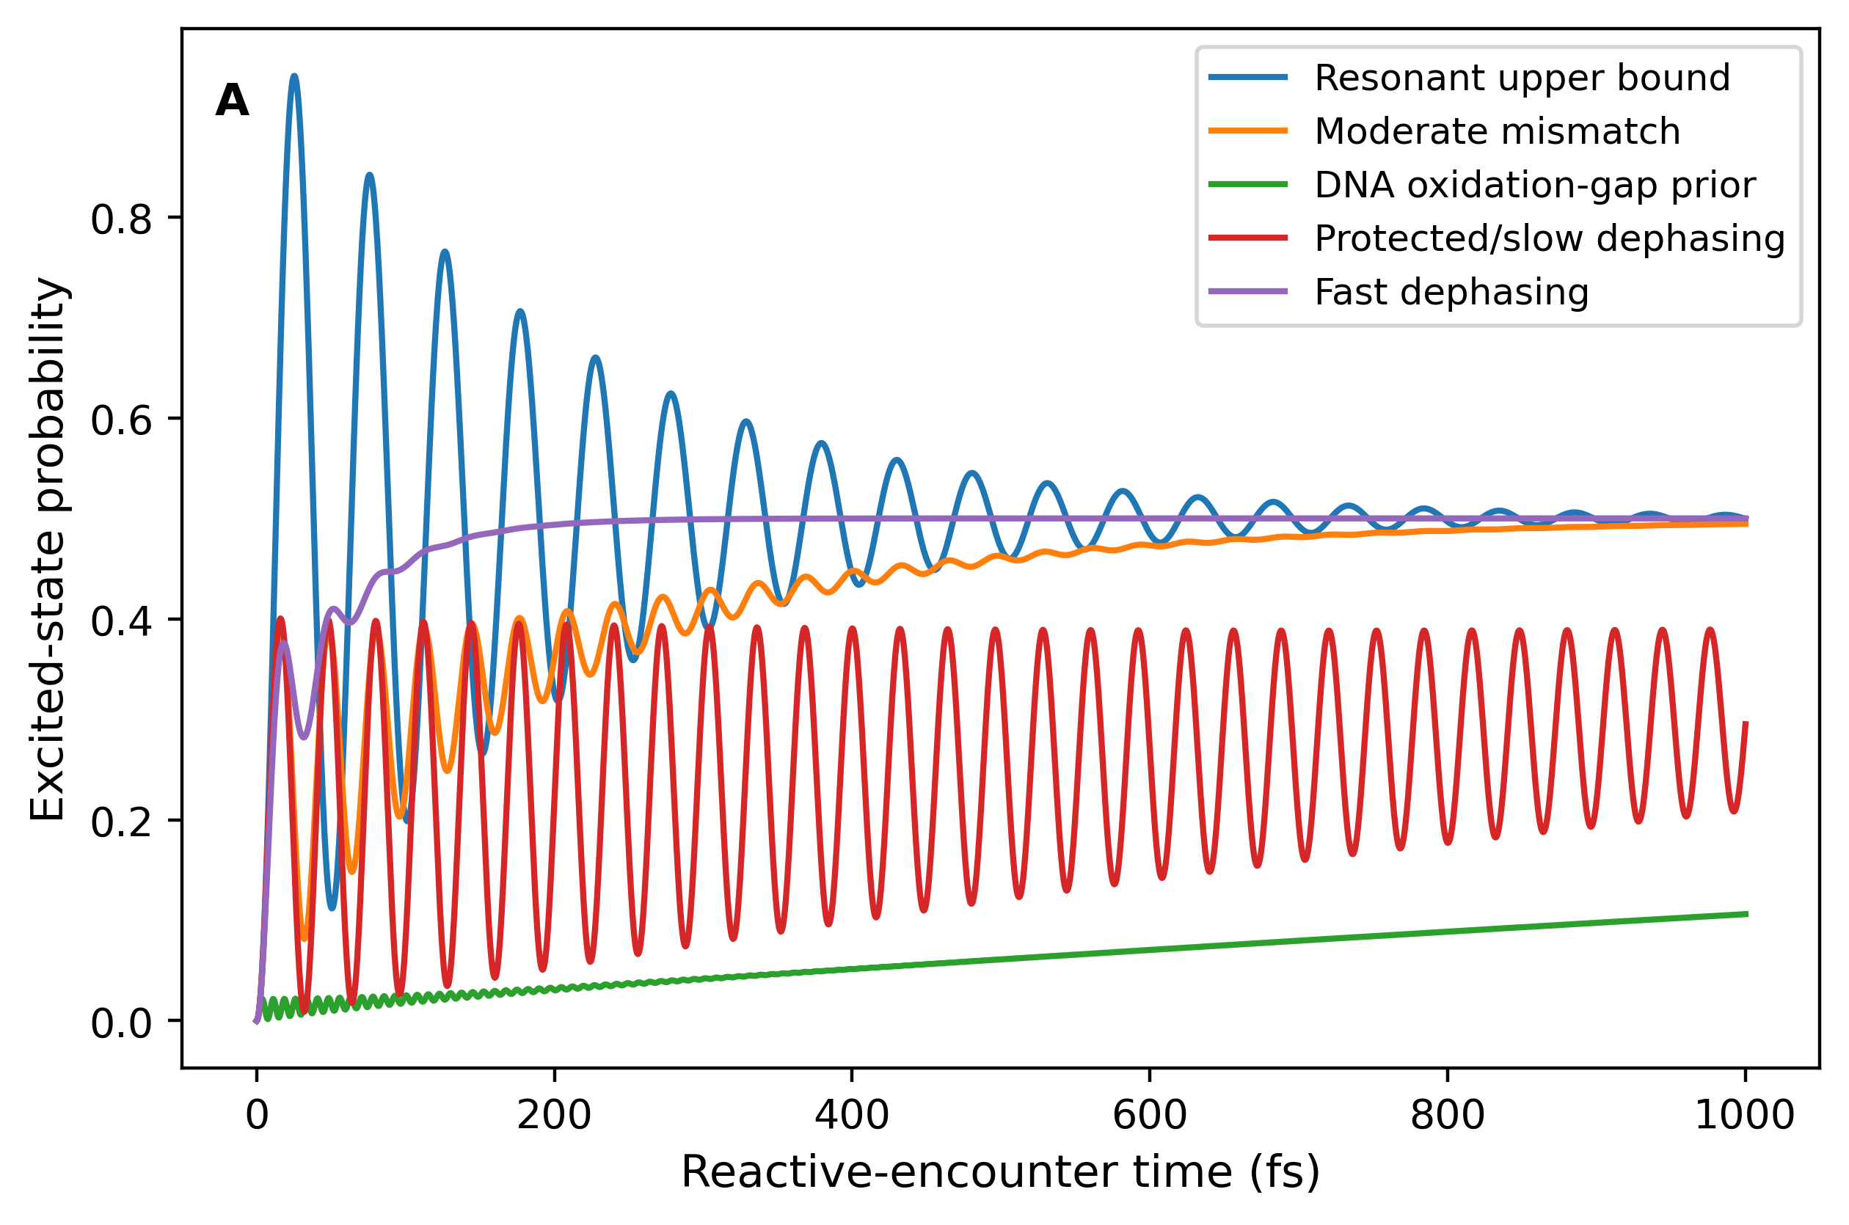
Figure 1. Microscopic ROS-mediated Rabi-like sensitivity analysis. The external electronic-coupling prior produces a 50.5-fs Rabi-like period. Detuning and dephasing strongly alter the excited-state probability, supporting use of an incoherent ensemble chemical pump at the biological scale. The coupling and detuning values are external biomolecular priors, not infection-specific measurements.

Table 2. Microscopic two-state sensitivity to energetic mismatch and dephasing.

Case | Detuning (eV) | Dephasing time (fs) | Rabi-like period (fs) | Maximum excited probability | Time of maximum (fs)
Resonant upper bound | 0.00 | 100 | 50.5 | 0.940 | 25.5
Moderate mismatch | 0.10 | 100 | 50.5 | 0.495 | 1000.0
DNA oxidation-gap prior | 0.55 | 100 | 50.5 | 0.106 | 1000.0
Protected/slow dephasing | 0.10 | 1000 | 50.5 | 0.400 | 16.0
Fast dephasing | 0.10 | 20 | 50.5 | 0.500 | 1000.0

4.2. Consistency with respiratory-burst inhibition

The two structural mappings were compared with the 40–50% residual PMA-induced UPE reported after diphenyleneiodonium (DPI) treatment of differentiated HL-60 cells[8] (Burgos et al., 2017). Under the PMA-constrained high-gain mapping, a nominal residual oxidative drive of 0.50 produced a DPI/PMA peak-UPE ratio of 0.448. Inverse calculation required a residual drive of 0.502 to reproduce a ratio of 0.45. The disease-saturating mapping predicted a ratio of 0.994 at 50% residual drive and required a much smaller residual drive of 0.019 to reproduce the same UPE ratio (Figure 2; Table 3A).

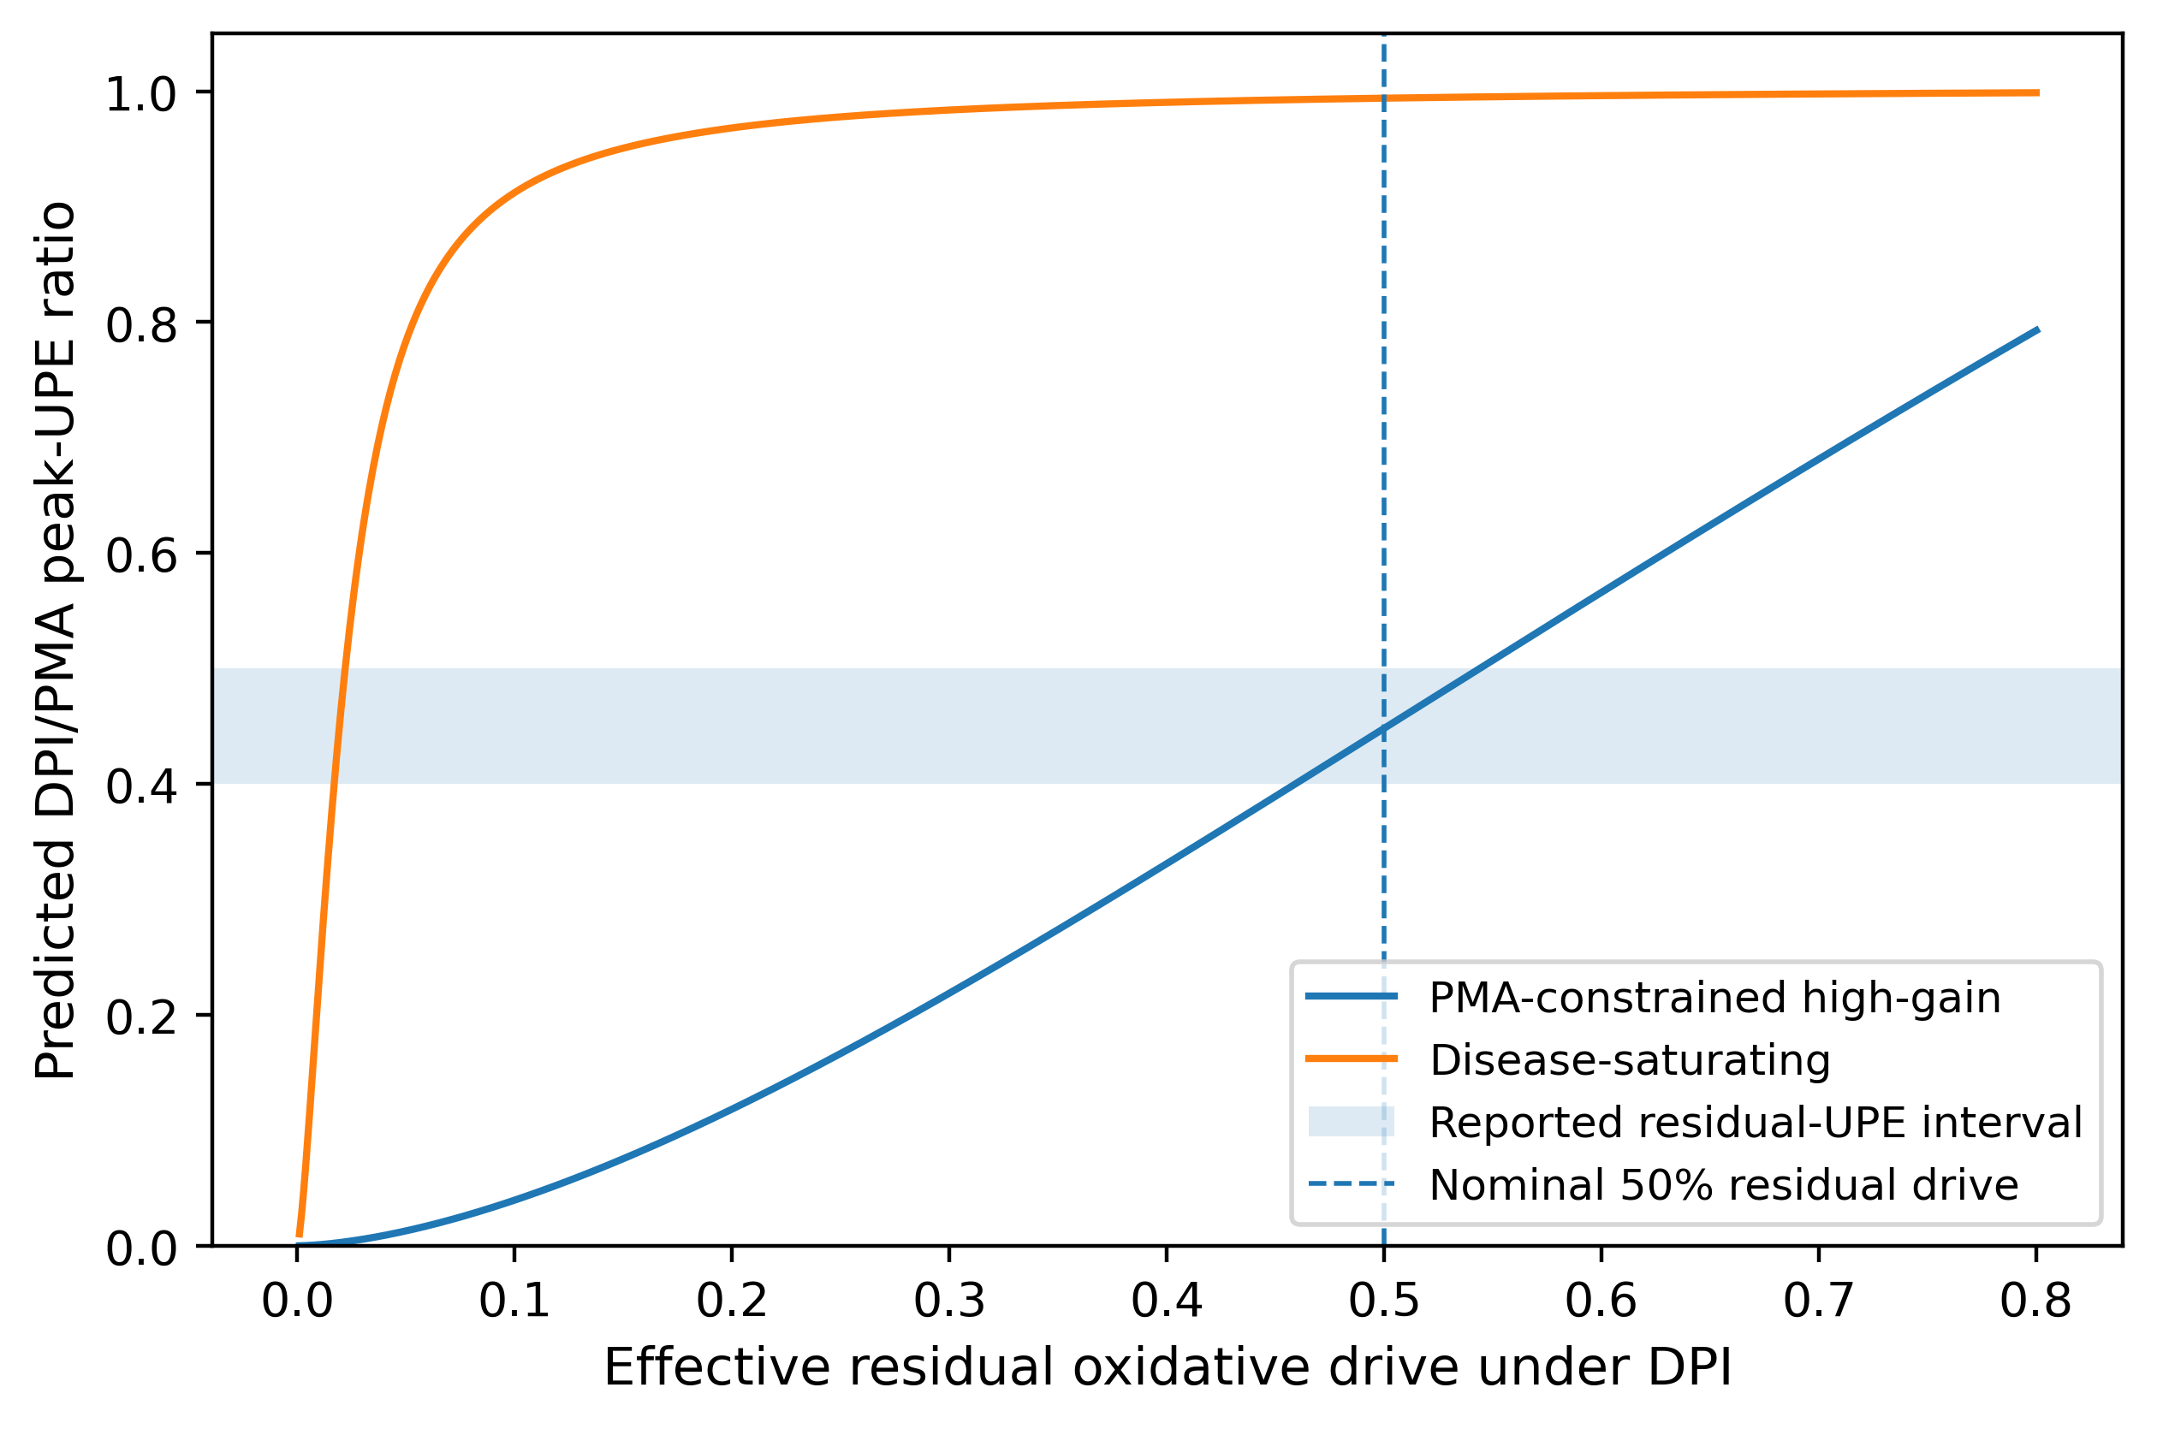
Figure 2. Structural dependence of the respiratory-burst inhibition response. The shaded band represents the reported 0.40–0.50 residual PMA-induced UPE after DPI treatment. The high-gain mapping reaches this interval near 50% residual oxidative drive, whereas the disease-saturating mapping requires almost complete suppression of the modeled oxidative drive.

Table 3A. Structural mapping definitions and DPI-response consistency.
Mapping | Gain | K_sat | Order shift | DPI/PMA at 50% drive | Drive required for ratio 0.45
PMA-constrained high-gain | 31.623 | 199.526 | 0.600 | 0.448 | 0.502
Disease-saturating | 1.778 | 1.000 | 0.400 | 0.994 | 0.019

Across 5,000 broad uncertainty realizations, 23.2% of high-gain simulations and none of the disease-saturating simulations fell within the reported 0.40–0.50 interval. Thus, the nominal high-gain mapping is compatible with the cell-level perturbation under an admissible parameterization, but the experiment does not uniquely determine the oxidative suppression factor or the downstream transfer function.

4.3. Structural dependence of disease-associated UPE predictions

The clinical ROS inputs generated markedly different disease-scale optical predictions under the two admissible structures. In the PMA-constrained high-gain mapping, nominal peak-UPE fold changes were 42.21 for severe COVID-19 and 89.02 for sepsis. Corresponding cumulative-emission fold changes were 41.97 and 88.55. In the disease-saturating mapping, peak fold changes were compressed to 1.445 and 1.450, while cumulative fold changes were 1.710 and 1.738 (Figures 3 and 4; Table 3B).

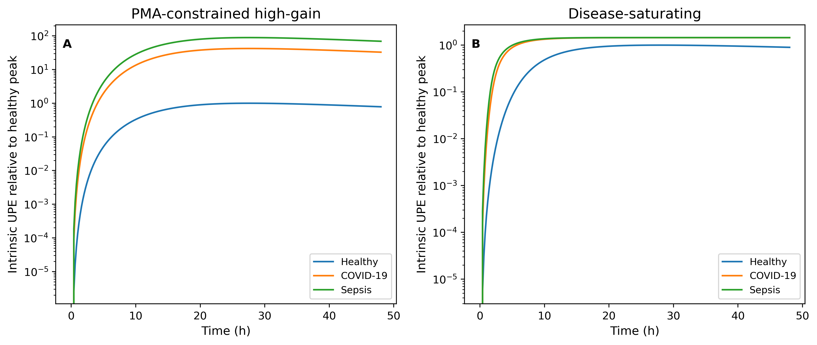
Figure 3. Time-dependent disease predictions under two mechanistically admissible ROS-to-UPE mappings. (A) The PMA-constrained high-gain structure amplifies the clinical oxidative inputs. (B) The disease-saturating structure compresses the same inputs into similar late-time optical responses. Curves are normalized to the healthy peak within each structural model.

Table 3B. Nominal disease-scale peak and cumulative UPE fold changes under the two structural mappings.
Mapping | COVID peak fold | Sepsis peak fold | COVID cumulative fold | Sepsis cumulative fold
PMA-constrained high-gain | 42.206 | 89.020 | 41.971 | 88.546
Disease-saturating | 1.445 | 1.450 | 1.710 | 1.738

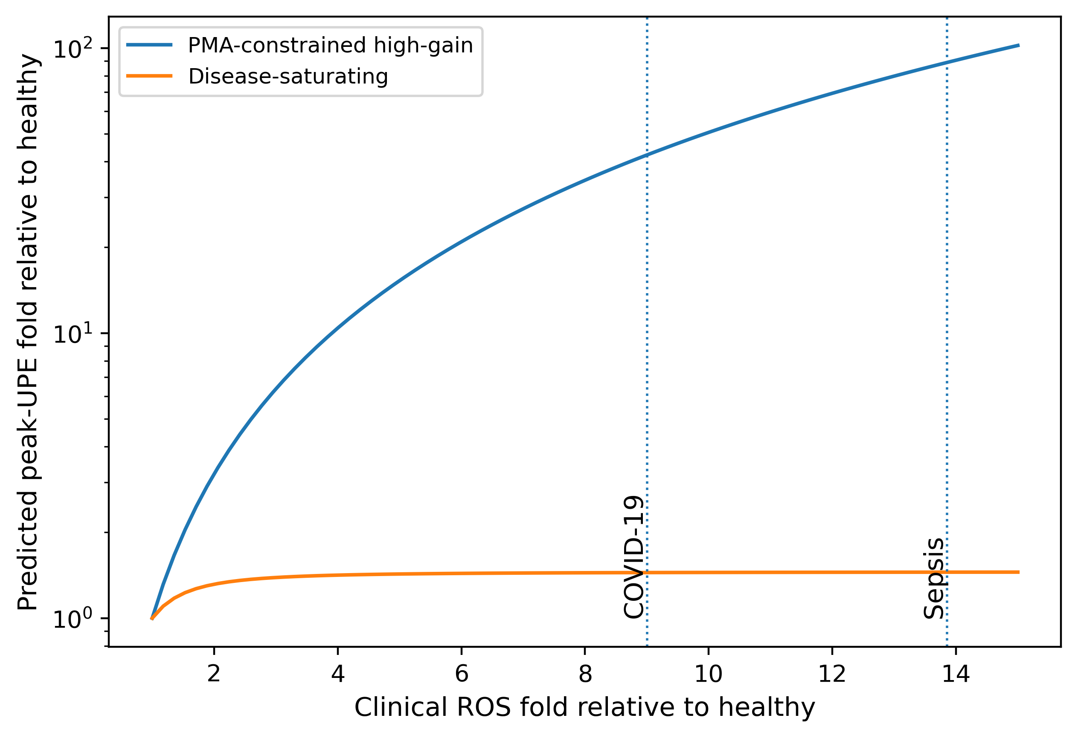
Figure 4. Structural prediction envelope across clinical ROS fold changes. The high-gain structure predicts continued amplification, whereas the saturating structure approaches a bounded peak response. Vertical lines mark the severe-COVID-19 and sepsis oxidative inputs.

Both mappings preserve the direction of the oxidative-to-optical pathway, but they differ by more than an order of magnitude in predicted disease response. This divergence demonstrates that clinical LIT measurements constrain the upstream oxidative regimes but do not identify a universal quantitative ROS-to-UPE transfer function that can be transported unchanged from differentiated HL-60 cells to clinical blood samples.

4.4. Prediction uncertainty and influential parameters

Uncertainty propagation reinforced the structural conclusion. Under the high-gain mapping, the median peak-UPE fold was 40.2 for COVID-19 and 81.8 for sepsis, but the 95% simulation intervals spanned several orders of magnitude. The disease-saturating structure produced substantially lower median responses, although its upper intervals also broadened when pathway parameters were varied simultaneously (Figure 5; Table 4). The nominal 42-fold and 89-fold values therefore represent conditional structural scenarios rather than uniquely identified biological predictions.

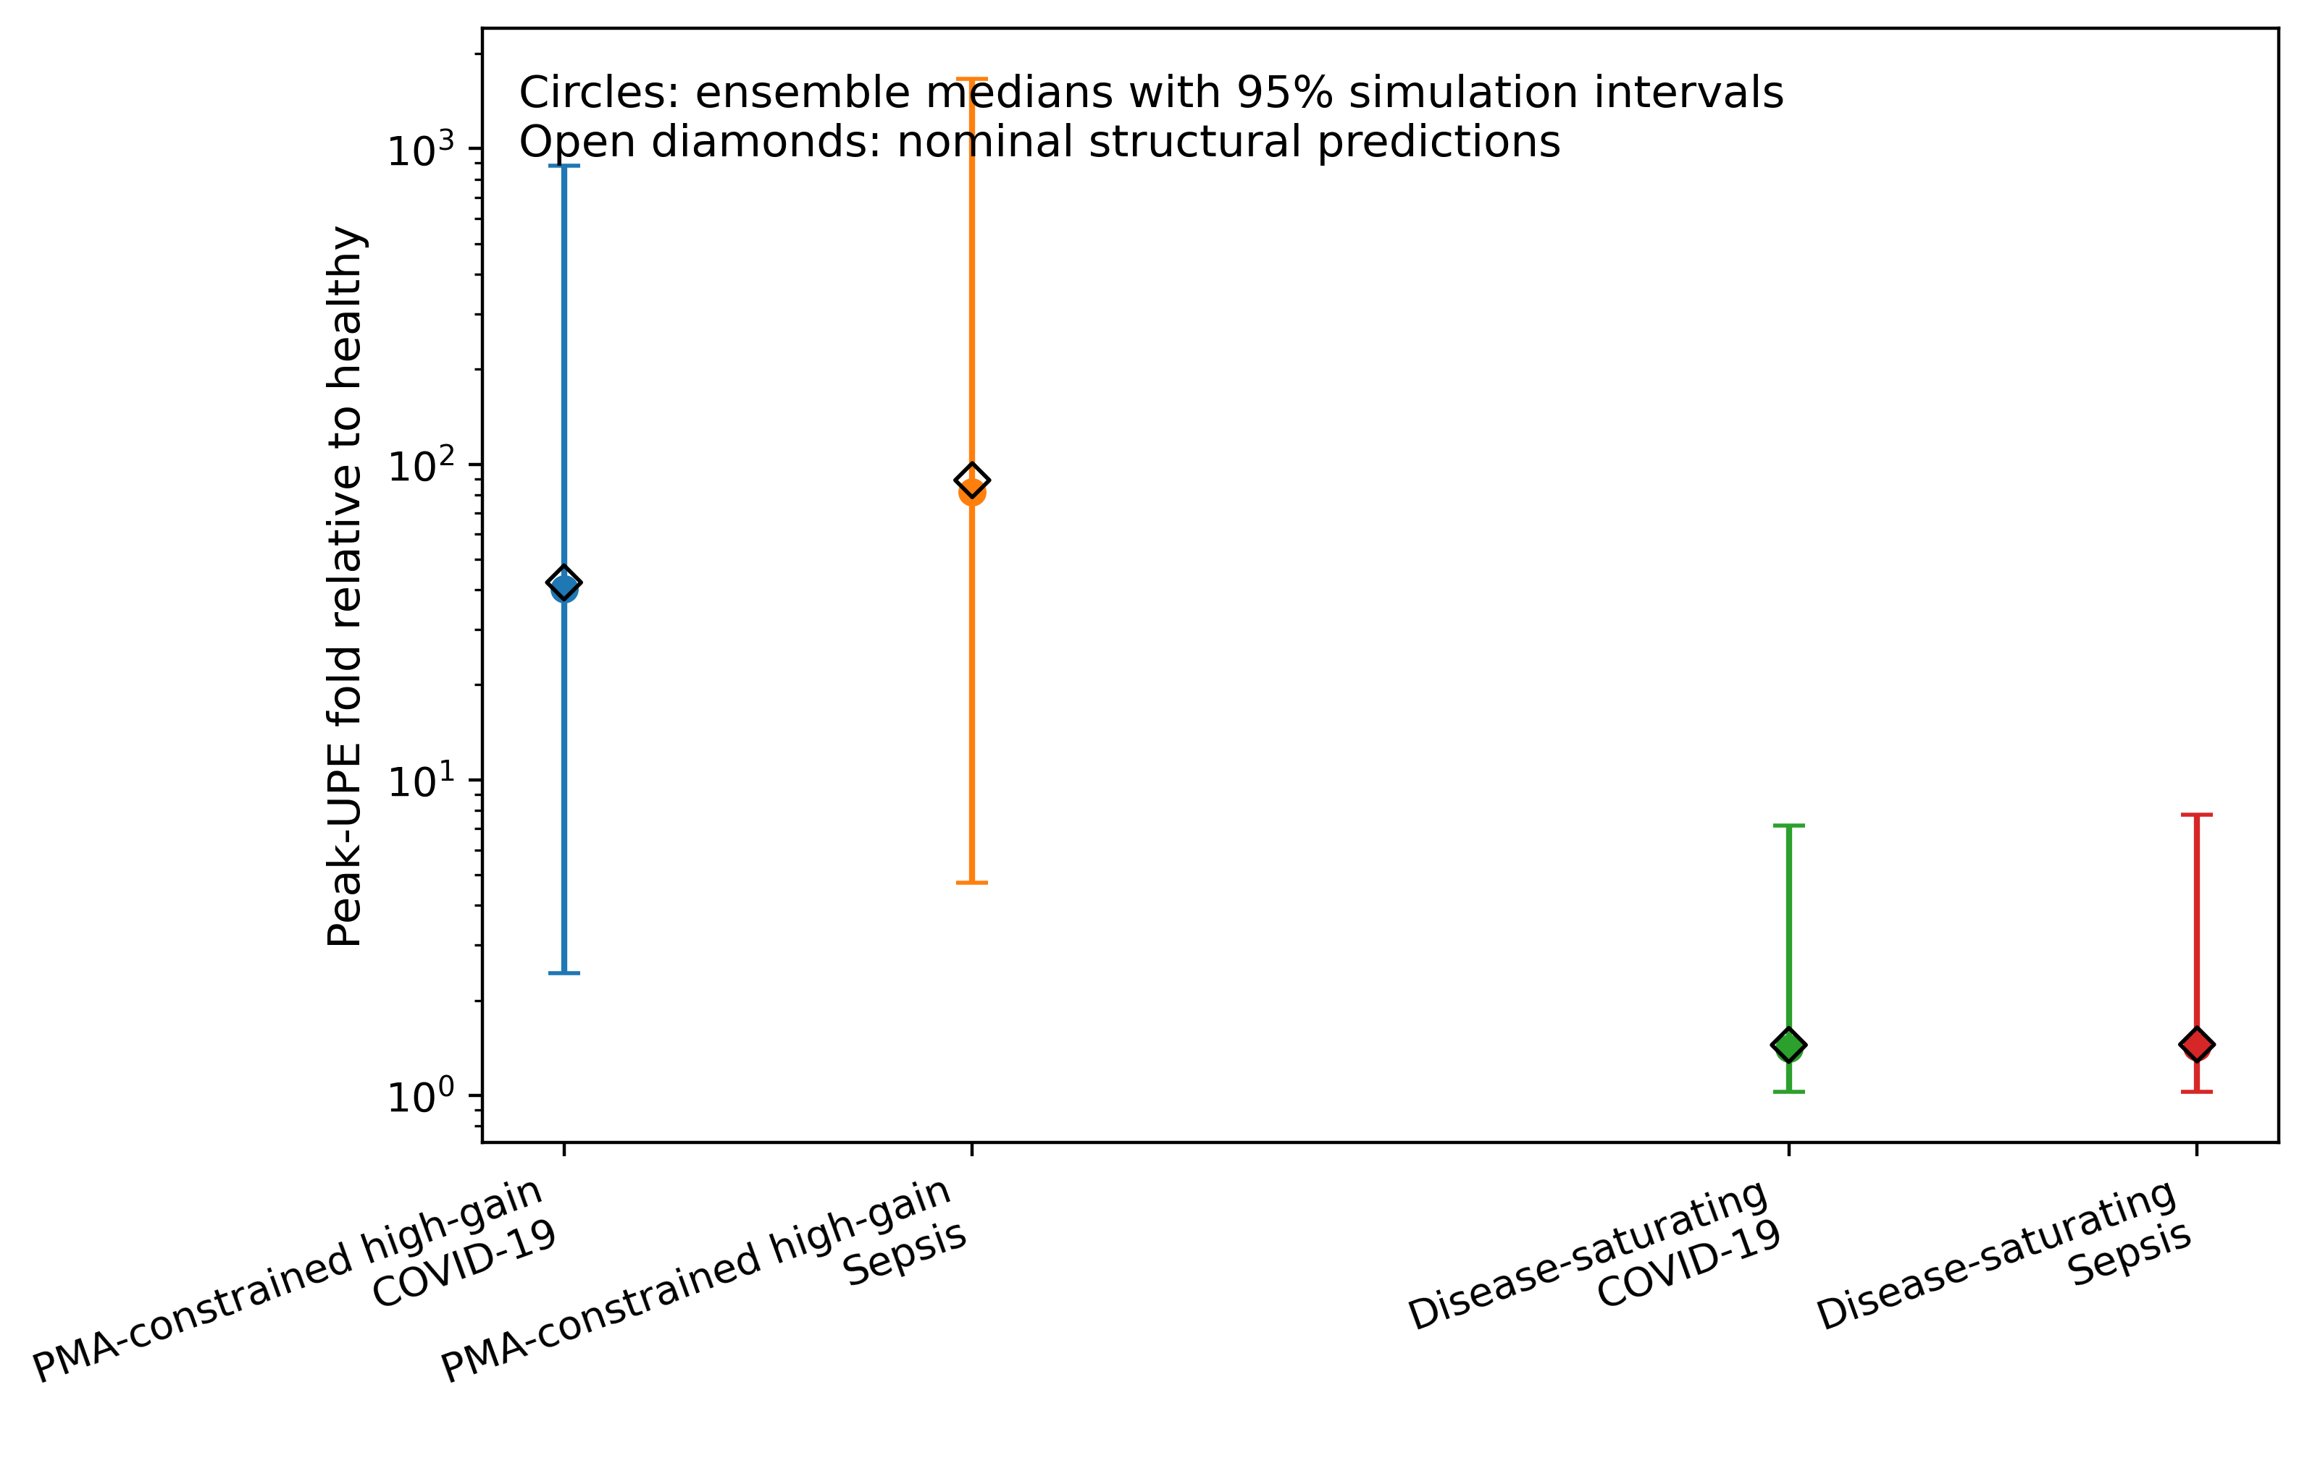
Figure 5. Ensemble uncertainty in disease-associated peak UPE. Circles show medians and 95% simulation intervals from 5,000 Latin-hypercube realizations; open diamonds show the nominal structural predictions. The logarithmic scale emphasizes the large uncertainty associated with the high-gain mapping.

Table 4. Structural mapping uncertainty for peak and cumulative UPE fold changes (5,000 realizations per mapping).
Mapping | Condition | Metric | Median | 95% simulation interval | IQR
PMA-constrained high-gain | COVID-19 | Peak | 40.19 | 2.44–881.04 | 95.74
PMA-constrained high-gain | COVID-19 | Cumulative | 40.05 | 2.45–895.49 | 96.12
PMA-constrained high-gain | Sepsis | Peak | 81.75 | 4.71–1661.04 | 198.17
PMA-constrained high-gain | Sepsis | Cumulative | 82.02 | 4.71–1681.48 | 199.65
Disease-saturating | COVID-19 | Peak | 1.41 | 1.02–7.17 | 0.99
Disease-saturating | COVID-19 | Cumulative | 1.66 | 1.10–8.46 | 1.27
Disease-saturating | Sepsis | Peak | 1.43 | 1.03–7.74 | 1.04
Disease-saturating | Sepsis | Cumulative | 1.71 | 1.12–9.42 | 1.37

The largest total-order contribution to sepsis peak-UPE variance was the saturation scale, followed by the emission-relevant oxidation decay rate, the signaling-to-emission conversion rate, the clinical sepsis ROS fold, and the composite pump gain (Figure 6; Table 6). These rankings show that uncertainty is controlled jointly by the measured oxidative input and the incompletely constrained conversion of oxidative chemistry into excited-state population.

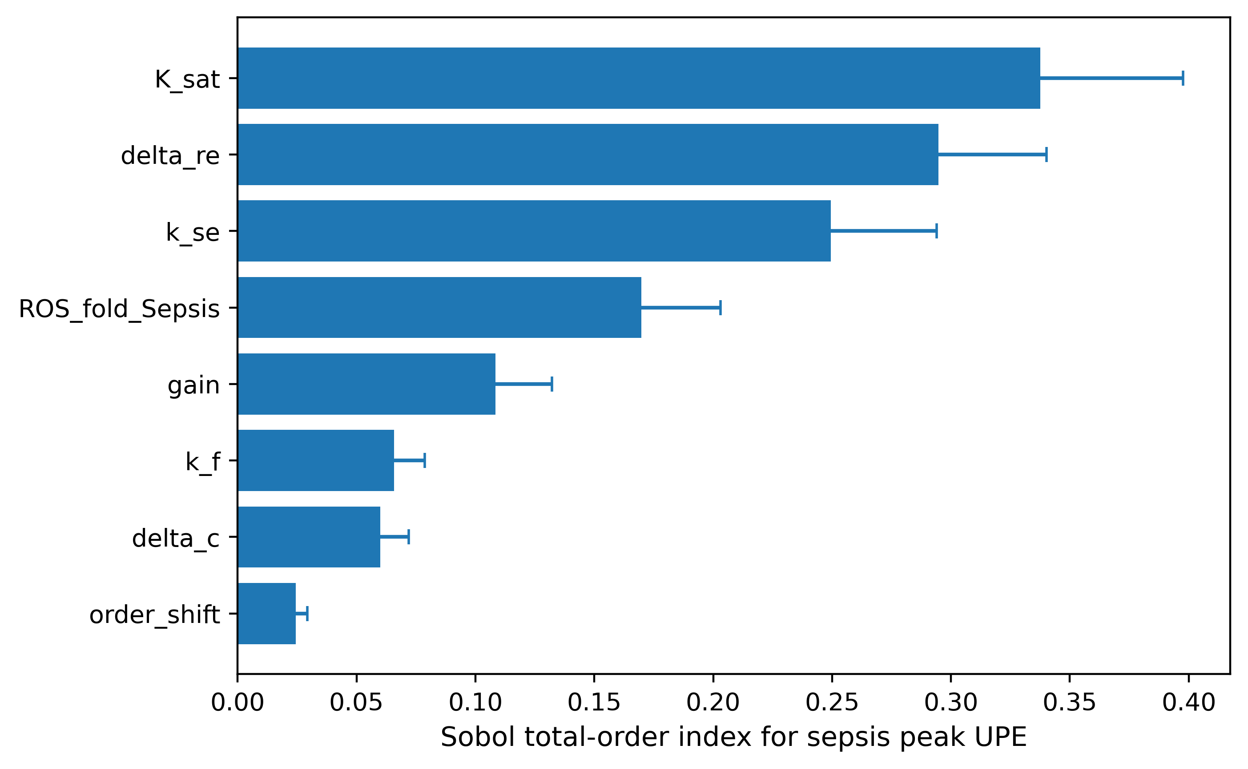
Figure 6. Total-order Sobol sensitivity indices for sepsis peak UPE under the high-gain mapping. Error bars show bootstrap 95% intervals. The saturation scale, emission-relevant oxidative lifetime, and signaling-to-emission conversion are the dominant unresolved determinants.

Table 6. First-order-free total-order Sobol sensitivity estimates for peak and cumulative sepsis UPE (base sample N = 2,048; 300 bootstrap resamples).
Parameter | Peak ST | Peak 95% CI | AUC ST | AUC 95% CI
K_sat | 0.338 | 0.288–0.398 | 0.345 | 0.294–0.408
delta_re | 0.295 | 0.255–0.340 | 0.275 | 0.238–0.318
k_se | 0.250 | 0.207–0.294 | 0.263 | 0.215–0.318
ROS_fold_Sepsis | 0.170 | 0.140–0.203 | 0.175 | 0.143–0.208
gain | 0.108 | 0.092–0.132 | 0.114 | 0.096–0.138
k_f | 0.066 | 0.056–0.079 | 0.071 | 0.060–0.085
delta_c | 0.060 | 0.051–0.072 | 0.055 | 0.047–0.065
order_shift | 0.025 | 0.021–0.029 | 0.030 | 0.025–0.035

4.5. Structural sensitivity of the spectral prediction

Measured oxidative-biomolecule peak locations and the 634-, 703-, and 1270-nm singlet-oxygen bands were retained as fixed channel centers [36,37]. Disease changed only the model-derived channel amplitudes. Voigt, Gaussian, and log-normal line-shape models all predicted a higher spectral centroid and red-to-blue ratio from healthy to COVID-19 to sepsis (Figure 7; Table 5). However, the exact centroid differed among line-shape families, and the emitter abundances were not measured in infection samples. The spectral result is therefore a structurally tested, hypothesis-generating prediction rather than a validated infection biomarker.

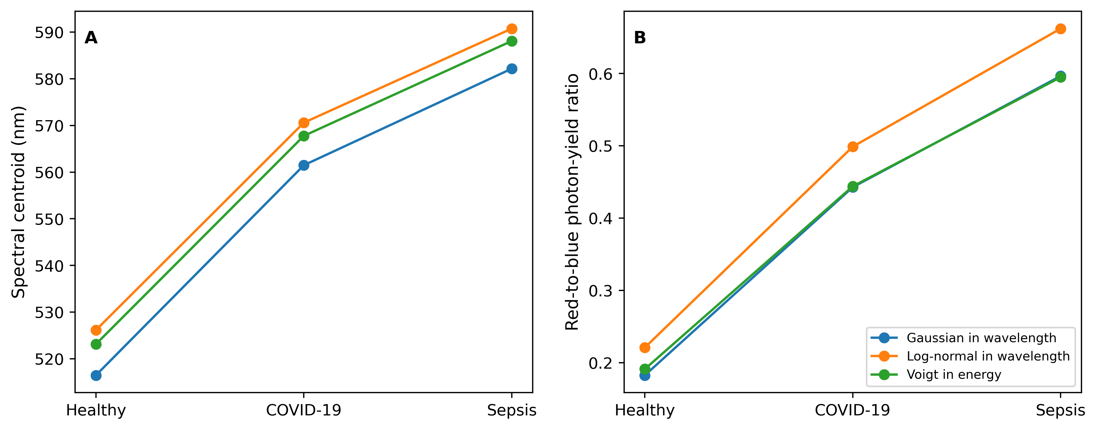
Figure 7. Sensitivity of the predicted spectral redistribution to line-shape choice. (A) Spectral centroid and (B) red-to-blue photon-yield ratio for Gaussian, log-normal, and Voigt representations. The direction of redistribution is preserved, while the exact values remain model dependent.

Table 5. Structural sensitivity of spectral centroid and red-to-blue photon-yield ratio.
Line-shape model | Condition | Centroid (nm) | Red-to-blue ratio
Voigt in energy | Healthy | 523.1 | 0.191
Voigt in energy | COVID-19 | 567.8 | 0.444
Voigt in energy | Sepsis | 588.1 | 0.595
Gaussian in wavelength | Healthy | 516.5 | 0.183
Gaussian in wavelength | COVID-19 | 561.5 | 0.443
Gaussian in wavelength | Sepsis | 582.2 | 0.597
Log-normal in wavelength | Healthy | 526.1 | 0.221
Log-normal in wavelength | COVID-19 | 570.6 | 0.499
Log-normal in wavelength | Sepsis | 590.8 | 0.662

4.6. Summary of publishable findings

The analysis supports three conclusions. First, a microscopic ROS-mediated electron-transfer encounter can be represented by a Rabi-like coupling scale, while energetic mismatch and rapid dephasing justify an incoherent chemical-pump description at the biological ensemble level. Second, the modeled oxidative-to-photon pathway can reproduce the direction and nominal magnitude of respiratory-burst inhibition under an admissible high-gain parameterization. Third, the existing literature does not uniquely identify a cross-system quantitative transfer function: high-gain and saturating structures remain mechanistically plausible but yield widely separated disease-scale UPE predictions. The robust result is therefore the pathway topology and the identification of gain, saturation, oxidative-intermediate lifetime, and quenching as the critical unresolved determinants of disease-associated UPE magnitude.

5. Discussion

5.1. Mechanistic support versus quantitative transportability

The present results distinguish support for a mechanistic pathway from validation of a disease-specific numerical prediction. The literature supports immune-associated ROS production, oxidative formation of electronically excited species, and suppression of UPE following inhibition of the respiratory burst. However, the clinical LIT assay and the differentiated HL-60 UPE experiment measure different observables in different biological preparations. The former is a PMA/luminol measure of leukocyte ROS-generating capacity, whereas the latter is spontaneous photon emission measured from cultured neutrophil-like cells. Their combination supports a shared pathway but does not establish a common pathway gain, emitter abundance, saturation scale, or quenching environment. This distinction is consistent with our earlier systems-level analysis, which showed that literature-constrained oxidative inputs support the direction of the oxidative-to-photon pathway more strongly than they constrain its quantitative magnitude [16].

5.2. Interpretation of the 42-fold and 89-fold scenario

The approximate 42-fold COVID-19 and 89-fold sepsis values should be retained as outputs of the PMA-constrained high-gain structure, not presented as clinically validated emission magnitudes. Their scientific value is to show what follows if the cell-level transfer function is transported unchanged to the clinical oxidative folds. The alternative saturating structure shows that the same clinical inputs can produce approximately 1.45-fold peak responses. Reporting both structures exposes the key unresolved biological question rather than concealing it through selection of one parameter set.

5.3. Experimental implications

The structural divergence yields specific experimental priorities. Paired measurements of spontaneous UPE, ROS-generating capacity, viable neutrophil number, lipid-peroxidation products, and spectral emission in the same preparation would directly constrain pathway gain and saturation. Until such data are available, disease-specific emission values should be reported as structural prediction envelopes. The present framework remains useful for experimental design because it identifies the measurements most capable of discriminating between amplification and saturation regimes.

5.4. Limitations

The clinical ROS distributions were reconstructed from reported medians and total IQR widths under a log-symmetric assumption. The microscopic electronic-coupling and reorganization-energy values were external DNA electron-transfer priors, not direct measurements of infection-associated oxidative reactions. The spectral channel centers came from controlled oxidative or photochemical systems rather than infection samples. Although the expanded uncertainty and sensitivity analyses improve numerical robustness, they cannot replace paired experimental observations of ROS and spontaneous UPE.

6. Conclusion

This study developed a multiscale quantum-kinetic framework connecting within-host infection dynamics, immune activation, signaling reactive oxygen species, emission-relevant oxidative chemistry, chemiexcitation-capable intermediates, molecular electron transfer, excited-state population dynamics, and ultraweak photon emission. The framework separates the biological production of ROS from the downstream molecular processes that generate electronically excited products, thereby avoiding the assumption that total ROS concentration is directly proportional to photon emission.
At the microscopic level, an individual ROS-mediated electron-transfer encounter was represented by a two-state electronic coupling and an associated Rabi-like frequency,

$$Ω_{ROS}=\frac{2∣V∣}{ℏ}.$$
The external biomolecular coupling used in the sensitivity analysis produced an illustrative Rabi-like period of approximately 50.5 fs. Energetic mismatch and environmental dephasing strongly reduced or overdamped the corresponding population exchange, supporting the use of an incoherent chemical-pump description at the biological ensemble level. The microscopic calculation should therefore be interpreted as a mechanistic bridge between electron-transfer theory and ensemble chemiexcitation, rather than as evidence for synchronized or long-lived quantum coherence in infected tissues.
The principal quantitative finding was the strong structural dependence of disease-associated UPE. When the severe-COVID-19 and sepsis oxidative regimes were propagated through a high-gain transfer structure, the nominal peak-UPE fold changes were approximately 42.21 and 89.02, respectively. In contrast, a saturating structure transformed the same oxidative inputs into peak-UPE fold changes of approximately 1.45 for both conditions. These values are not competing experimental measurements and should not be interpreted as clinically validated emission magnitudes. Instead, they define a structurally plausible prediction envelope and demonstrate that the available clinical ROS data do not uniquely determine the gain, saturation scale, emitter abundance, or quenching environment of the downstream oxidative-to-radiative pathway.
The respiratory-burst inhibition analysis provided a complementary pathway-level consistency test. Under the nominal high-gain structure and an assumed residual oxidative drive of approximately 50%, the model produced a DPI/PMA peak-UPE ratio of 0.448, within the experimentally reported interval of 0.40–0.50. However, this agreement was not preserved throughout the complete uncertainty ensemble, and the effective degree of ROS suppression produced by DPI was not independently measured in the same experiment. The comparison therefore supports the plausibility of the modeled oxidative-to-emission pathway but does not validate a unique transfer function or identify individual microscopic rate constants.
Global uncertainty and sensitivity analyses further showed that disease-associated UPE is governed jointly by the clinical oxidative input and the incompletely constrained downstream conversion process. The saturation scale, emission-relevant oxidative decay rate, signaling-to-emission conversion coefficient, disease-associated ROS fold, and composite pump gain were the principal determinants of predicted peak emission. These results identify the specific molecular and biochemical quantities that require experimental measurement to reduce model uncertainty.
The wavelength-resolved analysis similarly produced structurally constrained rather than clinically validated predictions. Gaussian, log-normal, and Voigt representations all preserved the modeled direction of increasing spectral centroid and red-to-blue photon-yield ratio from healthy to severe-COVID-19 and sepsis regimes. Nevertheless, the exact spectral values remained dependent on line-shape selection and on emitter populations that have not been measured in infection-associated samples. The predicted spectral redistribution should therefore be regarded as a testable hypothesis concerning altered oxidative-emitter populations.
Overall, the principal contribution of this work is the establishment of a physically continuous pathway,

$$\text{infection}→\text{immune activation}→\text{signaling ROS}→\text{emission-relevant oxidation}→\text{electron transfer and chemiexcitation}→\text{excited molecular states}→\text{UPE}.$$
The study demonstrates that support for this pathway does not imply that one universal numerical ROS-to-UPE relationship can be transported unchanged across cell culture, whole-blood assays, and clinical disease states. The framework instead identifies the amplification, saturation, temporal, and spectral regimes permitted by current knowledge and provides a quantitative basis for designing future paired measurements of ROS, oxidative intermediates, spontaneous UPE, and wavelength-resolved emission. It should therefore be interpreted as a mechanistic and hypothesis-generating computational framework, not as a clinically validated diagnostic model of COVID-19 or sepsis.

Data and Code Availability Statement: No new human-participant or animal data were generated in this study. The clinical oxidative-stress inputs, respiratory-burst intervention measurements, electron-transfer parameters, photophysical lifetimes, and spectral constraints were obtained from the published sources cited in the article. The processed literature-derived input tables, complete simulation source code, parameter definitions and uncertainty distributions, solver settings, random seeds, Latin Hypercube and Sobol sampling matrices, microscopic electron-transfer calculations, time-dependent model outputs, wavelength-resolved spectral templates, detector-response functions, structural-model definitions, and scripts used to reproduce every figure and table are openly available in [REPOSITORY NAME] at [PERMANENT DOI], archived as release [VERSION NUMBER]. Intrinsic biological spectra, detector-processed spectra, and background-corrected signals are provided as separate machine-readable files to preserve traceability between the biological and measurement models.

References
- Popp, F.-A.; Li, K.H.; Gu, Q., Eds. Recent Advances in Biophoton Research and Its Applications; World Scientific: Singapore, 1992.
- Cifra, M.; Pospíšil, P. Ultra-weak photon emission from biological samples: Definition, mechanisms, properties, detection and applications. J. Photochem. Photobiol. B 2014, 139, 2–10. doi:10.1016/j.jphotobiol.2014.02.009.
- Pospíšil, P.; Prasad, A.; Rác, M. Role of reactive oxygen species in ultra-weak photon emission in biological systems. J. Photochem. Photobiol. B 2014, 139, 11–23. doi:10.1016/j.jphotobiol.2014.02.008.
- Lambeth, J.D. NOX enzymes and the biology of reactive oxygen. Nat. Rev. Immunol. 2004, 4, 181–189. doi:10.1038/nri1312.
- Nathan, C.; Cunningham-Bussel, A. Beyond oxidative stress: An immunologist’s guide to reactive oxygen species. Nat. Rev. Immunol. 2013, 13, 349–361. doi:10.1038/nri3423.
- Krafft, C.; Dietzek, B.; Schmitt, M.; Popp, J. Raman and coherent anti-Stokes Raman scattering microspectroscopy for biomedical applications. J. Biomed. Opt. 2012, 17, 040801. doi:10.1117/1.JBO.17.4.040801.
- Lui, H.; Zhao, J.; McLean, D.; Zeng, H. Real-time Raman spectroscopy for in vivo skin cancer diagnosis. Cancer Res. 2012, 72, 2491–2500. doi:10.1158/0008-5472.CAN-11-4061.
- Burgos, R.C.R.; Schoeman, J.C.; van Winden, L.J.; Červinková, K.; Ramautar, R.; Van Wijk, E.P.A.; Cifra, M.; Berger, R.; Hankemeier, T.; van der Greef, J. Ultra-weak photon emission as a dynamic tool for monitoring oxidative stress metabolism. Sci. Rep. 2017, 7, 1229. doi:10.1038/s41598-017-01229-x.
- Shanei, A.; Alinasab, Z.; Kiani, A.; Nematollahi, M.A. Detection of ultraweak photon emission from cells as a tool for pathological studies. J. Biomed. Phys. Eng. 2017, 7, 389–396. doi:10.22086/jbpe.v0i0.458.
- Halliwell, B. Cell culture, oxidative stress, and antioxidants: Avoiding pitfalls. Biomed. J. 2014, 37, 99–105. doi:10.4103/2319-4170.128725.
- Jagannathan, L.; Cuddapah, S.; Costa, M. Oxidative stress under ambient and physiological oxygen tension in tissue culture. Curr. Pharmacol. Rep. 2016, 2, 64–72. doi:10.1007/s40495-016-0050-5.
- Slawinski, J. Photon emission from perturbed and dying organisms: Biomedical perspectives. Forsch. Komplementärmed. Klass. Naturheilkd. 2005, 12, 90–95. doi:10.1159/000083971.
- Engel, G.S.; Calhoun, T.R.; Read, E.L.; Ahn, T.-K.; Mančal, T.; Cheng, Y.-C.; Blankenship, R.E.; Fleming, G.R. Evidence for wavelike energy transfer through quantum coherence in photosynthetic systems. Nature 2007, 446, 782–786. doi:10.1038/nature05678.
- Ritz, T.; Adem, S.; Schulten, K. A model for photoreceptor-based magnetoreception in birds. Biophys. J. 2000, 78, 707–718. doi:10.1016/S0006-3495(00)76629-X.
- Veenith, T.; Martin, H.; Le Breuilly, M.; Whitehouse, T.; Gao-Smith, F.; Duggal, N.; Lord, J.M.; Mian, R.; Sarphie, D.; Moss, P. High generation of reactive oxygen species from neutrophils in patients with severe COVID-19. Sci. Rep. 2022, 12, 10484. doi:10.1038/s41598-022-13825-7.
- Crogman, H.T.; Alvarez, G.; Clement, P.U.; Sonawane, R.B.; Chidananda, R.; Khan, H.; Eshun, K.; Joseph, E.; Erenso, D.B. A multiscale mechanistic framework linking infection dynamics, oxidative chemiexcitation, and ultraweak photon emission. Biophysica 2026, 6, 87. https://doi.org/10.3390/biophysica6050087
- Nowak, M.A.; May, R.M. Virus Dynamics: Mathematical Principles of Immunology and Virology; Oxford University Press: Oxford, UK, 2000. doi:10.1093/oso/9780198504184.001.0001.
- Perelson, A.S. Modelling viral and immune system dynamics. Nat. Rev. Immunol. 2002, 2, 28–36. doi:10.1038/nri700.
- Marcus, R.A. On the theory of oxidation–reduction reactions involving electron transfer. I. J. Chem. Phys. 1956, 24, 966–978. doi:10.1063/1.1742723.
- May, V.; Kühn, O. Charge and Energy Transfer Dynamics in Molecular Systems, 3rd ed.; Wiley-VCH: Weinheim, Germany, 2011. doi:10.1002/9783527633791.
- Wan, C., Fiebig, T., Schiemann, O., Barton, J. K., & Zewail, A. H. (2002). Femtosecond electron-transfer reactions in mono- and polynucleotides and in DNA. Journal of the American Chemical Society, 124, 9338–9344. https://doi.org/10.1021/ja0172363
- Reid, G.D.; Whittaker, D.J.; Day, M.A.; Turton, D.A.; Kayser, V.; Kelly, J.M.; Beddard, G.S. Femtosecond electron-transfer reactions in mono- and polynucleotides and in DNA. J. Am. Chem. Soc. 2002, 124, 5518–5527. doi:10.1021/ja0172363.
- Tong, G.S.M.; Kurnikov, I.V.; Beratan, D.N. Tunneling energy effects on GC oxidation in DNA. J. Phys. Chem. B 2002, 106, 2381–2392. doi:10.1021/jp013387g.
- Gorini, V.; Kossakowski, A.; Sudarshan, E.C.G. Completely positive dynamical semigroups of $N$-level systems. J. Math. Phys. 1976, 17, 821–825. doi:10.1063/1.522979.
- Lindblad, G. On the generators of quantum dynamical semigroups. Commun. Math. Phys. 1976, 48, 119–130. doi:10.1007/BF01608499.
- Breuer, H.-P.; Petruccione, F. The Theory of Open Quantum Systems; Oxford University Press: Oxford, UK, 2002.
- Harris, C.R.; Millman, K.J.; van der Walt, S.J.; Gommers, R.; Virtanen, P.; Cournapeau, D.; Wieser, E.; Taylor, J.; Berg, S.; Smith, N.J.; et al. Array programming with NumPy. Nature 2020, 585, 357–362. doi:10.1038/s41586-020-2649-2.
- Virtanen, P.; Gommers, R.; Oliphant, T.E.; Haberland, M.; Reddy, T.; Cournapeau, D.; Burovski, E.; Peterson, P.; Weckesser, W.; Bright, J.; et al. SciPy 1.0: Fundamental algorithms for scientific computing in Python. Nat. Methods 2020, 17, 261–272. doi:10.1038/s41592-019-0686-2.
- Hunter, J.D. Matplotlib: A 2D graphics environment. Comput. Sci. Eng. 2007, 9, 90–95. doi:10.1109/MCSE.2007.55.
- Egorov, S.Y.; Kamalov, V.F.; Koroteev, N.I.; Krasnovskii, A.A., Jr.; Toleutaev, B.N.; Zinukov, S.V. Rise and decay kinetics of photosensitized singlet oxygen luminescence in water: Measurements with nanosecond time-correlated single-photon counting technique. Chem. Phys. Lett. 1989, 163, 421–424. doi:10.1016/0009-2614(89)85161-9.
- McKay, M.D.; Beckman, R.J.; Conover, W.J. A comparison of three methods for selecting values of input variables in the analysis of output from a computer code. Technometrics 1979, 21, 239–245. doi:10.1080/00401706.1979.10489755.
- Marino, S.; Hogue, I.B.; Ray, C.J.; Kirschner, D.E. A methodology for performing global uncertainty and sensitivity analysis in systems biology. J. Theor. Biol. 2008, 254, 178–196. doi:10.1016/j.jtbi.2008.04.011.
- Sobol’, I.M. Global sensitivity indices for nonlinear mathematical models and their Monte Carlo estimates. Math. Comput. Simul. 2001, 55, 271–280. doi:10.1016/S0378-4754(00)00270-6.
- Saltelli, A.; Annoni, P.; Azzini, I.; Campolongo, F.; Ratto, M.; Tarantola, S. Variance-based sensitivity analysis of model output: Design and estimator for the total sensitivity index. Comput. Phys. Commun. 2010, 181, 259–270. doi:10.1016/j.cpc.2009.09.018.
- Hamamatsu Photonics K.K. H7360 Series Photosensor Modules: H7360-01 Technical Data Sheet; Hamamatsu Photonics K.K.: Hamamatsu, Japan; accessed 31 July 2026.
- Lengfelder, E.; Cadenas, E.; Sies, H. Effect of DABCO (1,4-diazabicyclo[2.2.2]octane) on singlet oxygen monomol (1270 nm) and dimol (634 and 703 nm) emission. FEBS Lett. 1983, 164, 366–370. doi:10.1016/0014-5793(83)80318-4.
- Tsuchida, K.; Kobayashi, M. Ultraviolet A irradiation induces ultraweak photon emission with characteristic spectral patterns from biomolecules present in human skin. Sci. Rep. 2020, 10, 21667. doi:10.1038/s41598-020-78884-0.

